LXLC(R)-40~65(mm)
Removable element woltman cold (hot) water meter

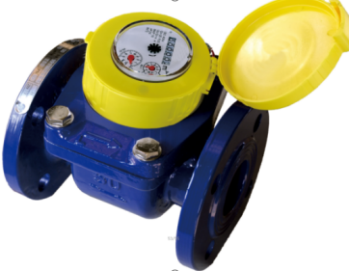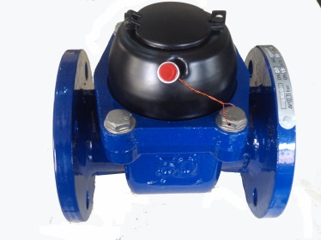

Application:
--Measuring the total volume of cold(hot) water passing through the pipeline.
-NOTE:This type of water meter can be used for a reading transmission system as equipped with pluse.
Feature:
-- Dry-dial, Magnetic drive
----Vacuum sealed register ensures the dial keep free from fog and Keep the reading clear in a long term service;
--Removable element unit and strong universality, easy installation and maintenance,
--Measuing high flow rate with low head loss.
-- Remote transmission device can be added upon request,such as Reed Swith or Hall, Pulse Output:DN40-65mm 1000L/P、100L/P.
--Technical data conform to international standard ISO 4064..
Working condition
Water temperature: T30 T50 T90
Water pressure class: MAP16 MAP10
Pressure-loss Class: △p63

Maximum permissible errors
(1) From minimum flow-rate(Q₁) inclusive to transitional flow-rate(Q₂) exclusive±5%.
(2) From transitional flow-rate(Q₂) to overload flow-rate(Q₄):±2%;
(Hot water meter ±3%)

MAIN TECHNICAL SPECIFICATIONS

Type | Size | Class | Q₄ Overload Flow | Q₃ Permanent Flow | Q₂ Transitional Flow | Q₁  Min. Flow | Min. Reading | Max. Reading
Type | Size | Class | m³/h |  |  |  | m³
LXLC-40 | 1½" | R50  (R80) | 31.25 | 25 | 0.8 | 0.5 | 0.0005 | 999,999
LXLC-50 | 2" | R50  (R80) | 31.25 | 25 | 0.8 | 0.5 | 0.0005 | 999,999
LXLC-65 | 2½" | R50  (R80) | 50 | 40 | 1.28 | 0.8 | 0.0005 | 999,999

DIMENSIONS

Type | Size |  | L  Length |  | H  Height | Connecting flange
 |  |  |  |  |  | φD1 Outside diameter | φD2 Bolt circle diameter | Connecting Bolts  (n-M)
Type | mm |  |  |  |  | φD1 Outside diameter | φD2 Bolt circle diameter | Connecting Bolts  (n-M)
LXLC-40 | 1½" | 200 |  | 210 |  | 150 | 110 | 4-M16
LXLC-50 | 2" | 200 |  | 214 |  | 165 | 125 | 4-M16
LXLC-65 | 2½" | 200 |  | 224 |  | 185 | 145 | 4-M16

NOTE: The flange dimension conforms to ISO7005-2:1988 standard. Order for products of special requirements is also accepted.

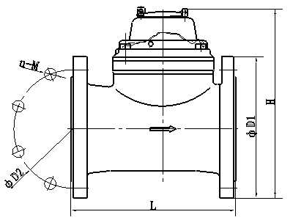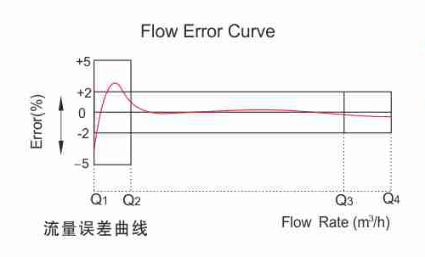

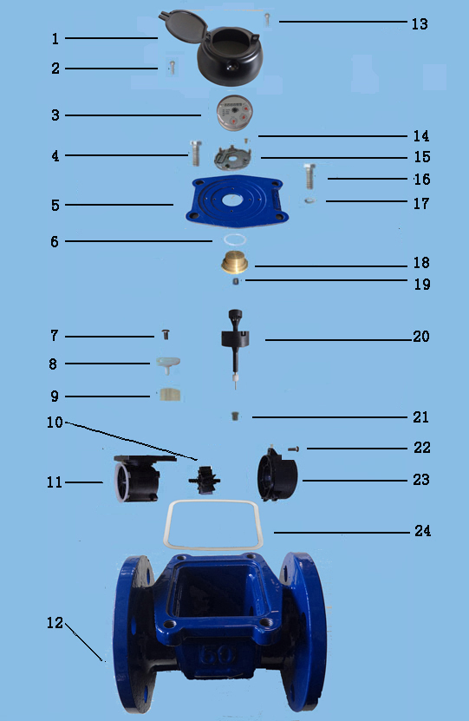
LXLC-40～65 REMOVABLE ELEMENT WOLTMAN WATER METER
Code | Description | Material | QTY
1 | Screw For Sealing | Stainless Steel | 1
2 | Cover With Lid | Assembly | 1
3 | Sealed Register | Assembly | 1
4 | Screw M4×20 | Stainless Steel | 2
5 | Flange Plate | Cast Iron | 2
6 | O-ring | Silicon Rubber | 1
7 | Screw | Stainless Steel | 1
8 | Adjusting Lever | POM OR MPPO | 1
9 | Adjusting Plate | POM OR MPPO | 1
10 | Turbine | ABS OR MPPO | 1
11 | Rectifier | ABS OR MPPO | 1
12 | Body | Casting Iron | 1
13 | Screw | Stainless Steel | 1
14 | Screw | Stainless Steel | 1
15 | Fixed plate | POM OR MPPO | 1
16 | Screw | Stainless Steel | 1
17 | Gasket | Stainless Steel | 1
18 | Upper Bearing Plate | Brass | 1
19 | Upper Bearing | Nylon With Graphite | 1
20 | Magnet Component | Component | 1
21 | Lower Bearing | Nylon With Graphite | 1
22 | Screw | Stainless Steel | 1
23 | Support | POM OR MPPO | 1
24 | Seal Gasket | Rubber | 1

----------------------------------------------------------------------------------------------------------------------
LIANYUNGANG HYTTEN METER CO.,LTD.
Add:No. 8 Hanguo Industrial Development Zone,Luoyang Village
Dunshang Town,Ganyu District, Lianyungang, Jiangsu, China
Tel: ++86-518-85907891
Fax: ++86-518-85907890 Postal code: 222000
E-mail: hytten@hyttenmeter.com
http://www.hyttenmeter.com www.hyttenwatermeter.com

