LXLC(R)-80~200(mm)
Removable element woltman cold (hot) water meter

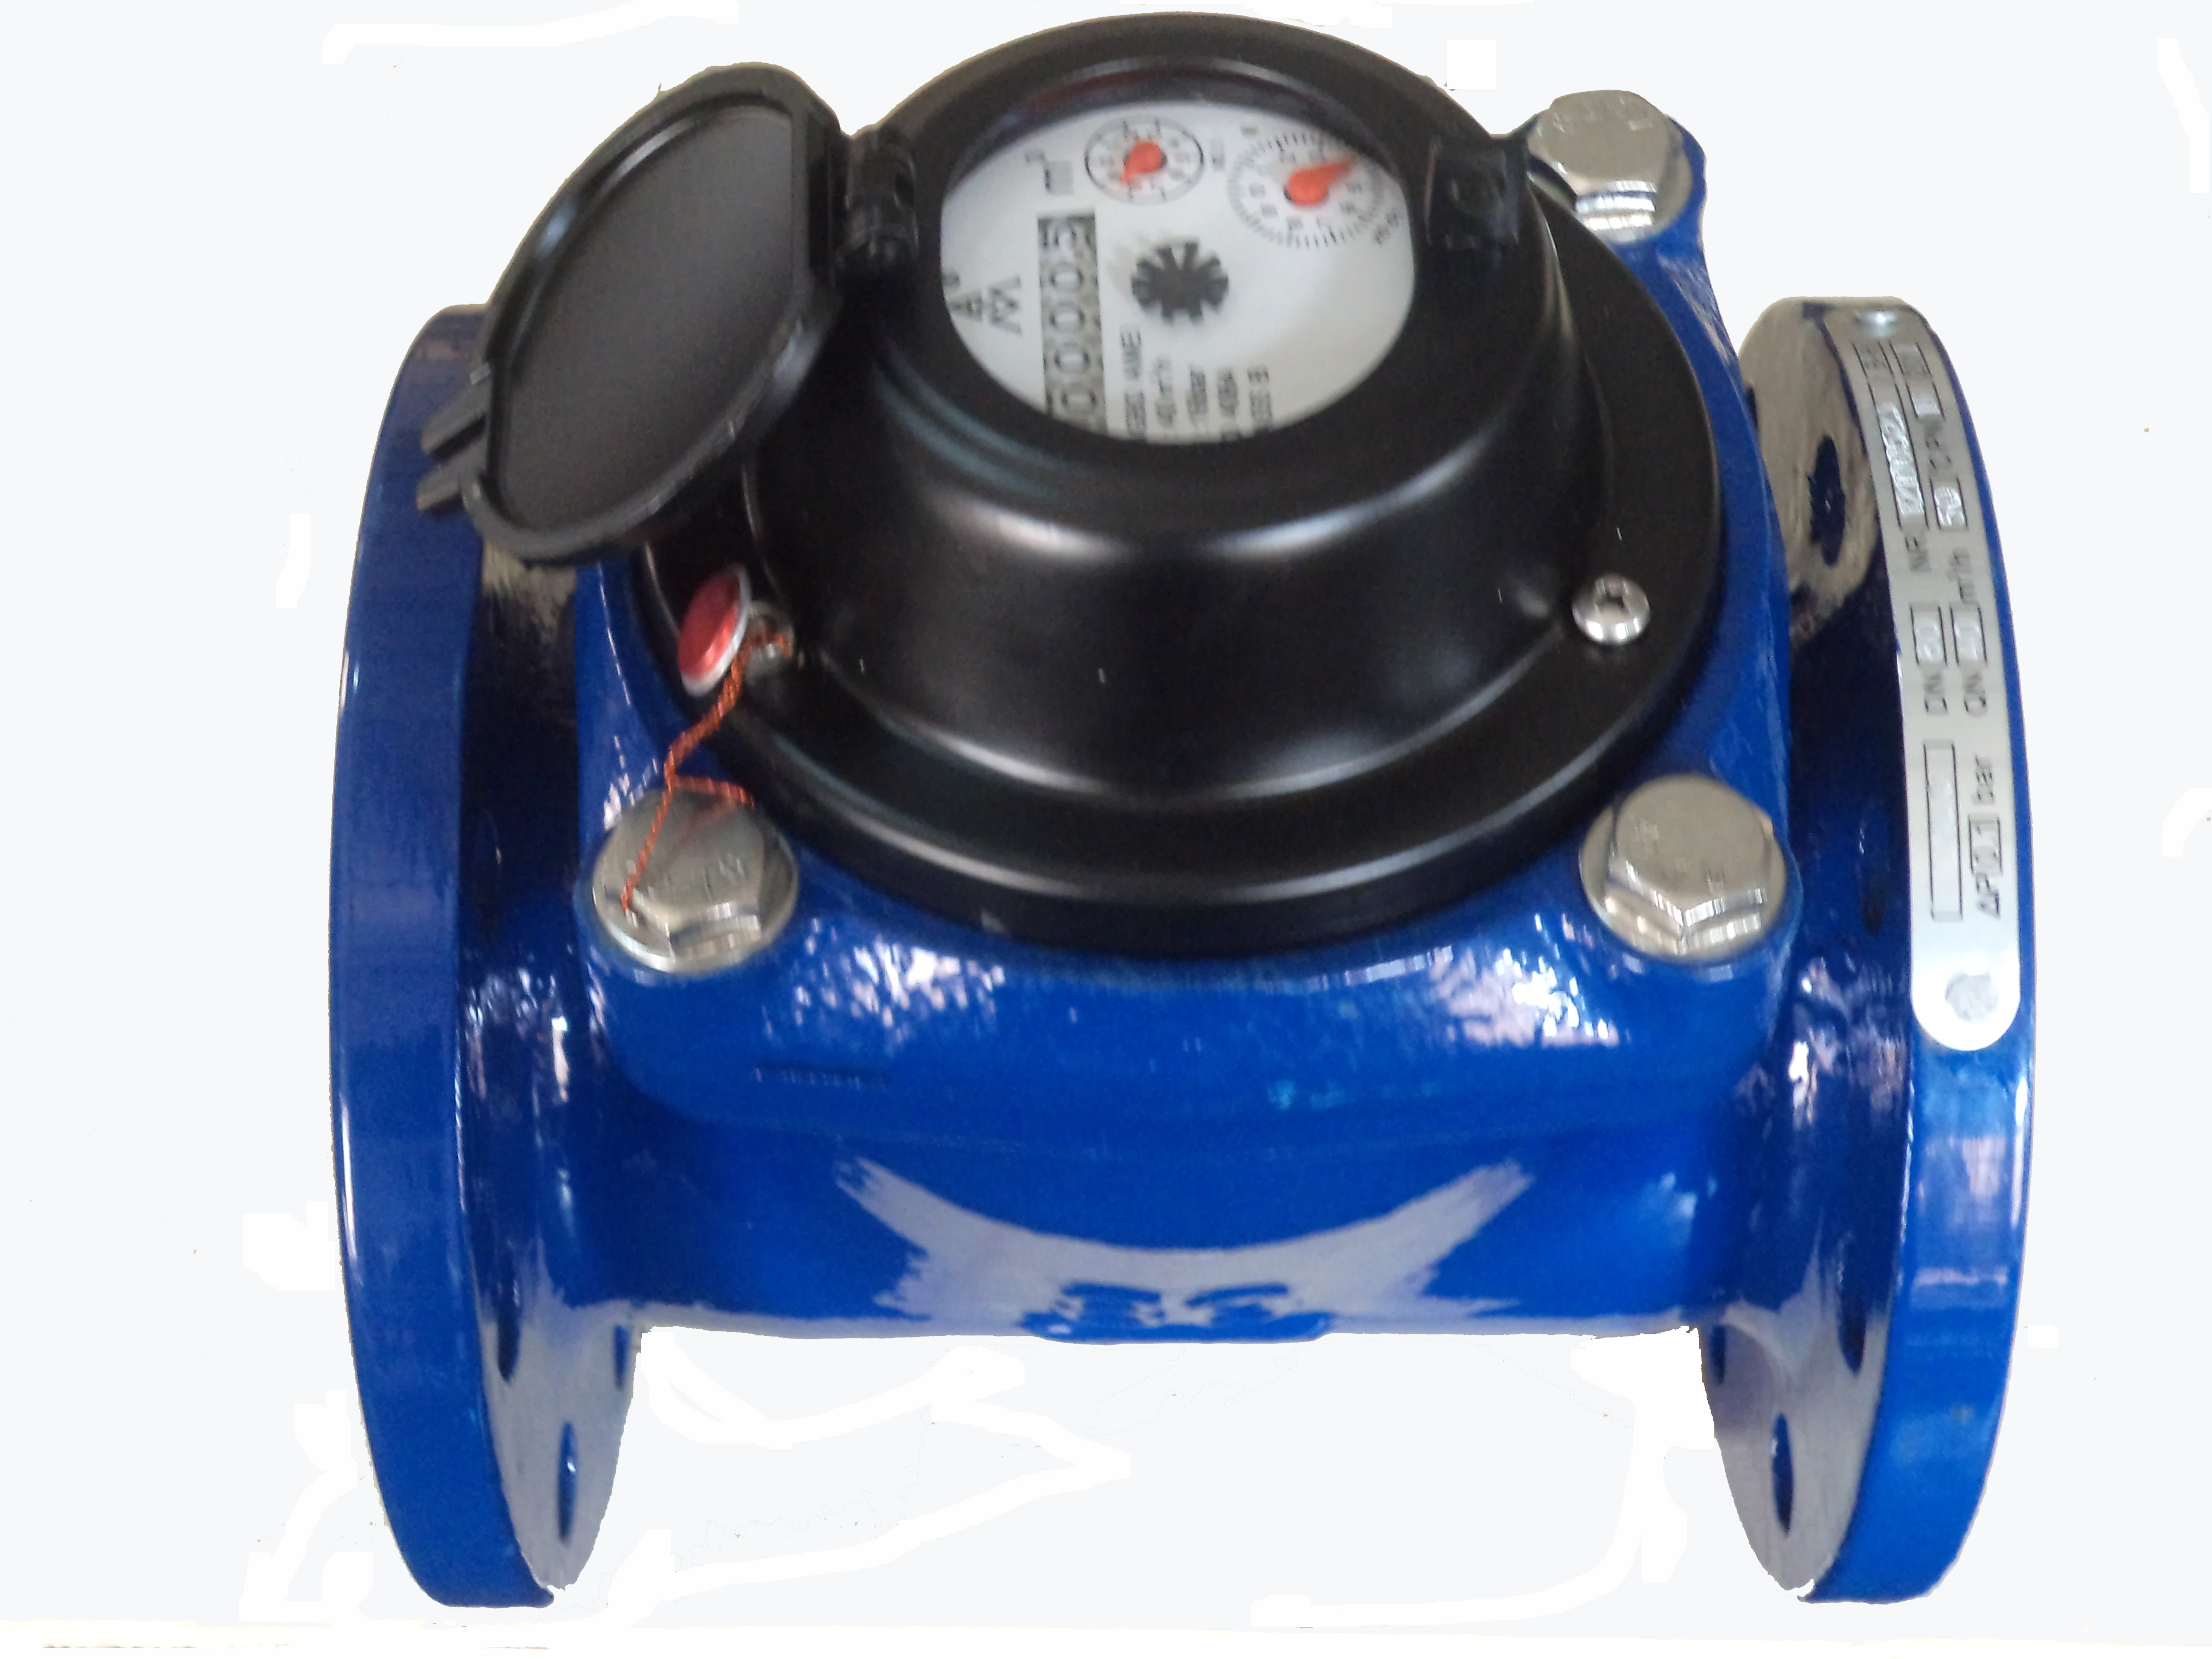

Application:
--Measuring the total volume of cold(hot) water passing through the pipeline.
-NOTE:This type of water meter can be used for a reading transmission system as equipped with pluse.
Feature:
-- Dry-dial, Magnetic drive
----Vacuum sealed register ensures the dial keep free from fog and Keep the reading clear in a long term service;
--Removable element unit and strong universality, easy installation and maintenance,
--Measuing high flow rate with low head loss.
-- Remote transmission device can be added upon request,such as Reed Swith or Hall, Pulse Output:DN80-200mm 1000L/P、100L/P.
--Technical data conform to international standard ISO 4064..
Working condition
Water temperature: T30 T50 T90
Water pressure class: MAP16 MAP10
Pressure-loss Class: △p63

Maximum permissible errors
(1) From minimum flow-rate(Q₁) inclusive to transitional flow-rate(Q₂) exclusive±5%.
(2) From transitional flow-rate(Q₂) to overload flow-rate(Q₄):±2%;
(Hot water meter ±3%)

MAIN TECHNICAL SPECIFICATIONS

Type | Size | Class | Q₄ Overload Flow | Q₃ Permanent Flow | Q₂ Transitional Flow | Q₁  Min. Flow | Min. Reading | Max. Reading
Type | Size | Class | m³/h |  |  |  | m³
LXLC-80 | 3" | R50  (R80) | 78.75 | 63 | 2 | 1.26 | 0.002 | 999,999
LXLC-100 | 4" | R50  (R80) | 125 | 100 | 3.2 | 2 | 0.002 | 999,999
LXLC-125 | 5" | R50  (R80) | 200 | 160 | 5.12 | 3.2 | 0.002 | 999,999
LXLC-150 | 6" | R50  (R80) | 312.5 | 250 | 8 | 5 | 0.002 | 999,999
LXLC-200 | 8" | R50  (R80) | 500 | 400 | 12.8 | 8 | 0.002 | 999,999

DIMENSIONS

Type | Size |  | L  Length |  | H  Height | Connecting flange
 |  |  |  |  |  | φD1 Outside diameter | φD2 Bolt circle diameter | Connecting Bolts  (n-M)
Type | mm |  |  |  |  | φD1 Outside diameter | φD2 Bolt circle diameter | Connecting Bolts  (n-M)
LXLC-80 | 3" | 225 |  | 279 |  | 200 | 160 | 8-M16
LXLC-100 | 4" | 250 |  | 289 |  | 220 | 180 | 8-M16
LXLC-125 | 5" | 250 |  | 299 |  | 250 | 210 | 8-M16
LXLC-150 | 6" | 300 |  | 319 |  | 285 | 240 | 8-M20
LXLC-200 | 8" | 350 |  | 346 |  | 340 | 295 | 8-M20(1.0MPa)
 |  |  |  |  |  |  |  | 12-M20(1.6MPa)

NOTE: The flange dimension conforms to ISO7005-2:1988 standard. Order for products of special requirements is also accepted.

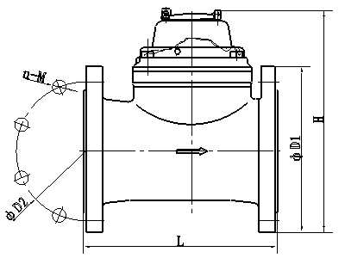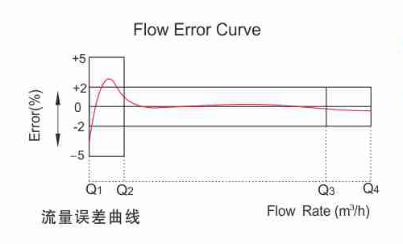
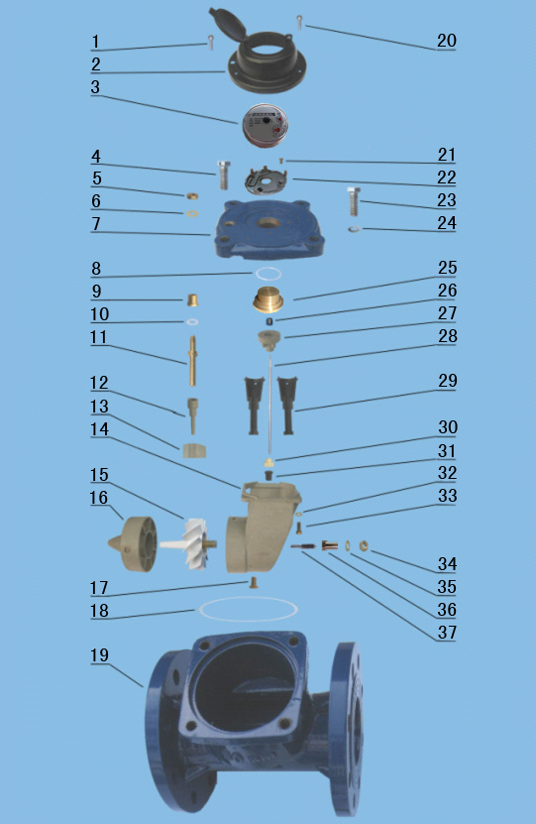
LXLC-80～200 REMOVABLE ELEMENT WOLTMAN WATER METER
Code | Description | Material | QTY
1 | Screw For Sealing | Stainless Steel | 1
2 | Cover With Lid | Assembly | 1
3 | Sealed Register | Assembly | 1
4 | Screw M4×20 | Stainless Steel | 2
5 | Gasket | Brass | 2
6 | Adjusting Nut | Brass | 1
7 | Flange Cover | Cast Iron | 1
8 | O-ring | Silicon Rubber | 1
9 | Bush | Brass | 1
10 | Gasket | Synthetic Rubber | 1
11 | Adjusting Lever | Brass | 1
12 | Connecting Lever | POM OR MPPO | 1
13 | Adjusting Plate | POM OR MPPO | 1
14 | Support | ABS OR MPPO | 1
15 | Turbine Component | Assembly | 1
16 | Rectifier | ABS OR MPPO | 1
17 | Screw | Brass | 1
18 | O-ring | Synthetic Rubber | 1
19 | Body | Cast Iron | 1
20 | Screw For Sealing | Stainless Steel | 1
21 | Screw For Sealing | Stainless Steel | 3
22 | Support | ABS | 1
23 | Screw M4×20 | Stainless Steel | 2
24 | Gasket | Stainless Steel | 4
25 | Upper Bearing Plate | Brass | 1
26 | Upper Bearing | Nylon With Graphite | 1
27 | Magnet Component | Component | 1
28 | Transmission Shaft | Stainless Steel | 1
29 | Sheath | Nylon | 2
30 | Bevel Gear | POM | 1
31 | Bevel Gear | Nylon | 1
32 | Gasket | Stainless Steel | 4
33 | ScrewM5X12 | Stainless Steel | 4
34 | Nut | Brass | 1
35 | Gasket | Brass | 1
36 | Turbine Shaft Hold | Brass | 1
37 | Turbine Shaft | Tungsten Steel | 1

----------------------------------------------------------------------------------------------------------------------
LIANYUNGANG HYTTEN METER CO.,LTD.
Add:No. 8 Hanguo Industrial Development Zone,Luoyang Village
Dunshang Town,Ganyu District, Lianyungang, Jiangsu, China
Tel: ++86-518-85907891
Fax: ++86-518-85907890 Postal code: 222000
E-mail: hytten@hyttenmeter.com
http://www.hyttenmeter.com www.hyttenwatermeter.com

