LXLC(R)-250~300(mm)
Removable element woltman cold (hot) water meter

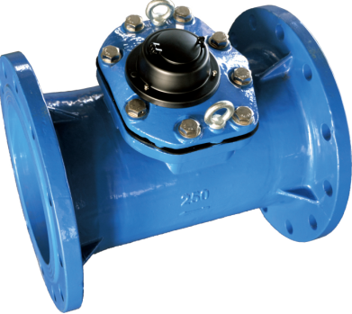

Application:
--Measuring the total volume of cold(hot) water passing through the pipeline.
-NOTE:This type of water meter can be used for a reading transmission system as equipped with pluse.
Feature:
-- Dry-dial, Magnetic drive
----Vacuum sealed register ensures the dial keep free from fog and Keep the reading clear in a long term service;
--Removable element unit and strong universality, easy installation and maintenance,
--Measuing high flow rate with low head loss.
-- Remote transmission device can be added upon request,such as Reed Swith or Hall, Pulse Output: DN250-300mm 10000L/P、1000L/P
--Technical data conform to international standard ISO 4064..
Working condition
Water temperature: T30 T50 T90
Water pressure class: MAP16 MAP10
Pressure-loss Class: △p63

Maximum permissible errors
(1) From minimum flow-rate(Q₁) inclusive to transitional flow-rate(Q₂) exclusive±5%.
(2) From transitional flow-rate(Q₂) to overload flow-rate(Q₄):±2%;
(Hot water meter ±3%)

MAIN TECHNICAL SPECIFICATIONS

Type | Size | Class | Q₄ Overload Flow | Q₃ Permanent Flow | Q₂ Transitional Flow | Q₁  Min. Flow | Min. Reading | Max. Reading
Type | Size | Class | m³/h |  |  |  | m³
LXLC-250 | 10" | R50  (R80) | 787.5 | 630 | 20.16 | 12.6 | 0.02 | 9999,999
LXLC-300 | 12" | R50  (R80) | 1250 | 1000 | 32 | 20 | 0.02 | 9,999,999

DIMENSIONS

Type | Size |  | L  Length |  | H  Height | Connecting flange
 |  |  |  |  |  | φD1 Outside diameter | φD2 Bolt circle diameter | Connecting Bolts  (n-M)
Type | mm |  |  |  |  | φD1 Outside diameter | φD2 Bolt circle diameter | Connecting Bolts  (n-M)
LXLC-250 | 10" | 450 |  | 434 |  | 395 | 350 | 12-M20(1.0MPa)
 |  |  |  |  |  | 405 | 355 | 12-M24(1.6MPa)
LXLC-300 | 12" | 500 |  | 480 |  | 445 | 400 | 12-M20(1.0MPa)
 |  |  |  |  |  | 460 | 410 | 12-M24(1.6MPa)

NOTE: The flange dimension conforms to ISO7005-2:1988 standard. Order for products of special requirements is also accepted.

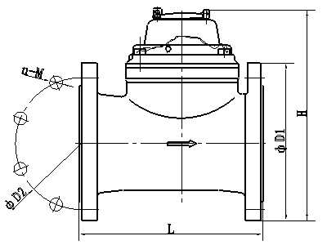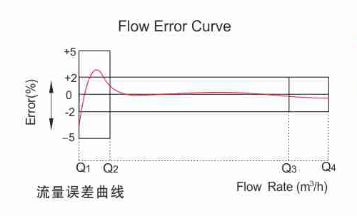

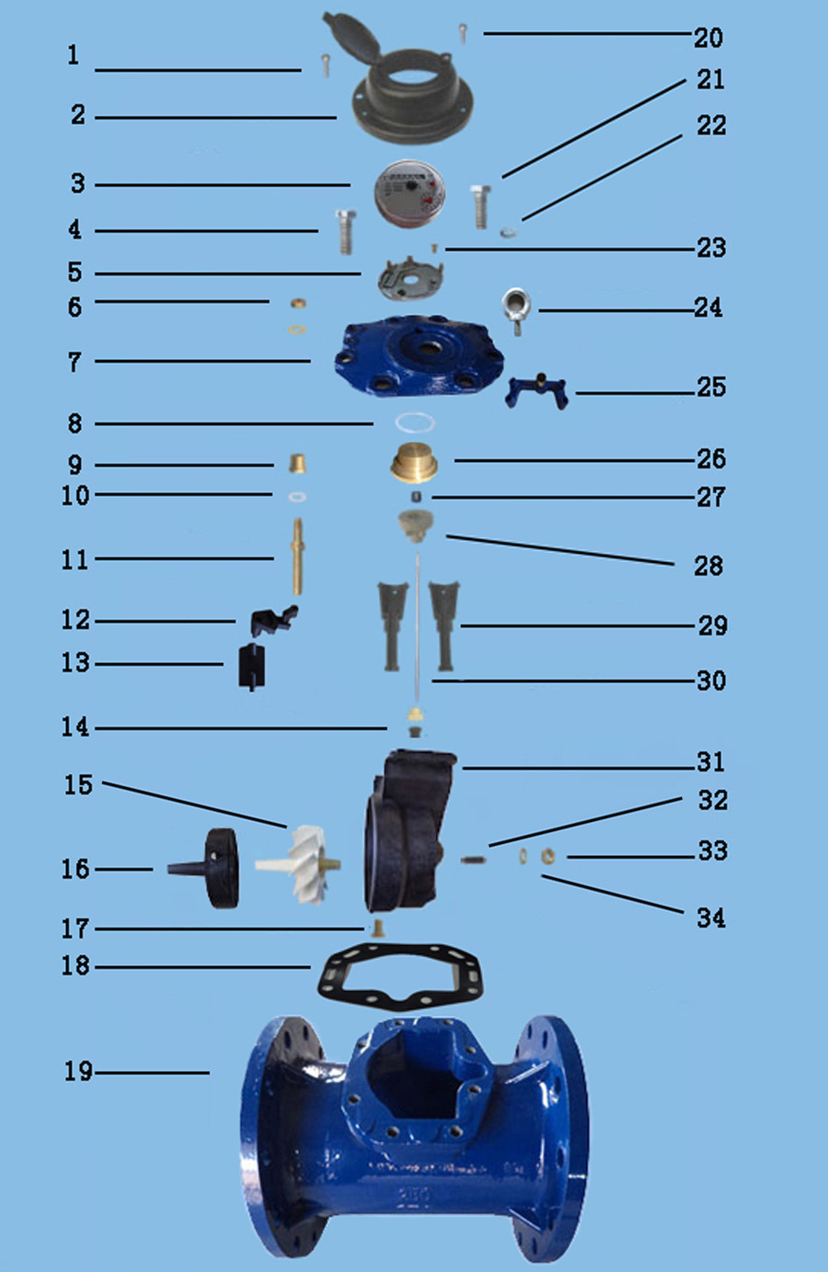

LXLC-250～300 REMOVABLE ELEMENT WOLTMAN WATER METER
Code | Description | Material | QTY
1 | Screw For Sealing | Stainless Steel | 1
2 | Cover With Lid | Assembly | 1
3 | Sealed Register | Assembly | 1
4 | Screw M16×45 | Stainless Steel | 1
5 | Fixed plate | PPO | 1
6 | Adjusting Nut | Brass and Silicon Rubber | 2
7 | Flange Cover | Cast Iron | 1
8 | O-ring | Silicon Rubber | 1
9 | Bush | Brass | 1
10 | Gasket | Synthetic Rubber | 1
11 | Adjusting Lever | Brass | 1
12 | Connecting Lever | Nylon | 1
13 | Adjusting Plate | Nylon | 1
14 | Support and gear | Nylon and pom | 1
15 | Turbine Component | Assembly | 1
16 | Rectifier | Nylon | 1
17 | Screw | Brass | 1
18 | O-ring | Synthetic Rubber | 1
19 | Body | Cast Iron | 1
20 | Screw For Sealing | Stainless Steel | 2
21 | Screw M16X45 | Stainless Steel | 7
22 | Gasket | Stainless Steel | 8
23 | Screw for fixing | Stainless Steel | 4
24 | rings | Stainless Steel | 2
25 | Gasket | Cast Iron | 1
26 | Upper Bearing Plate | Brass | 1
27 | Upper Bearing | Nylon With Graphite | 1
28 | Magnet Component | Component | 1
29 | Sheath | Nylon | 2
30 | Transmission Shaft | Stainless Steel | 1
31 | Support | Nylon | 1
32 | Turbine Shaft | Tungsten Steel | 1
33 | Screw | Brass | 1
34 | Nut | Brass | 1

----------------------------------------------------------------------------------------------------------------------
LIANYUNGANG HYTTEN METER CO.,LTD.
Address: No.9 Road XinLong Economic and Technological Development Zone Xinpu
Lianyungang, Jiangsu, China.
Tel: ++86-518-81069628 81069629
Fax: ++86-518-81069630 Postal code: 222000
E-mail:982801898@qq.com;hytten@hyttenmeter.com
Web: http://www.hyttenmeter.com //www.hyttenwatermeter.com

