LXLC-350~600(mm)
Removable element woltman cold water meter
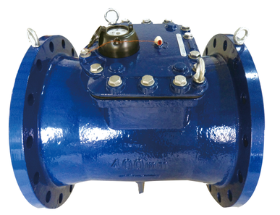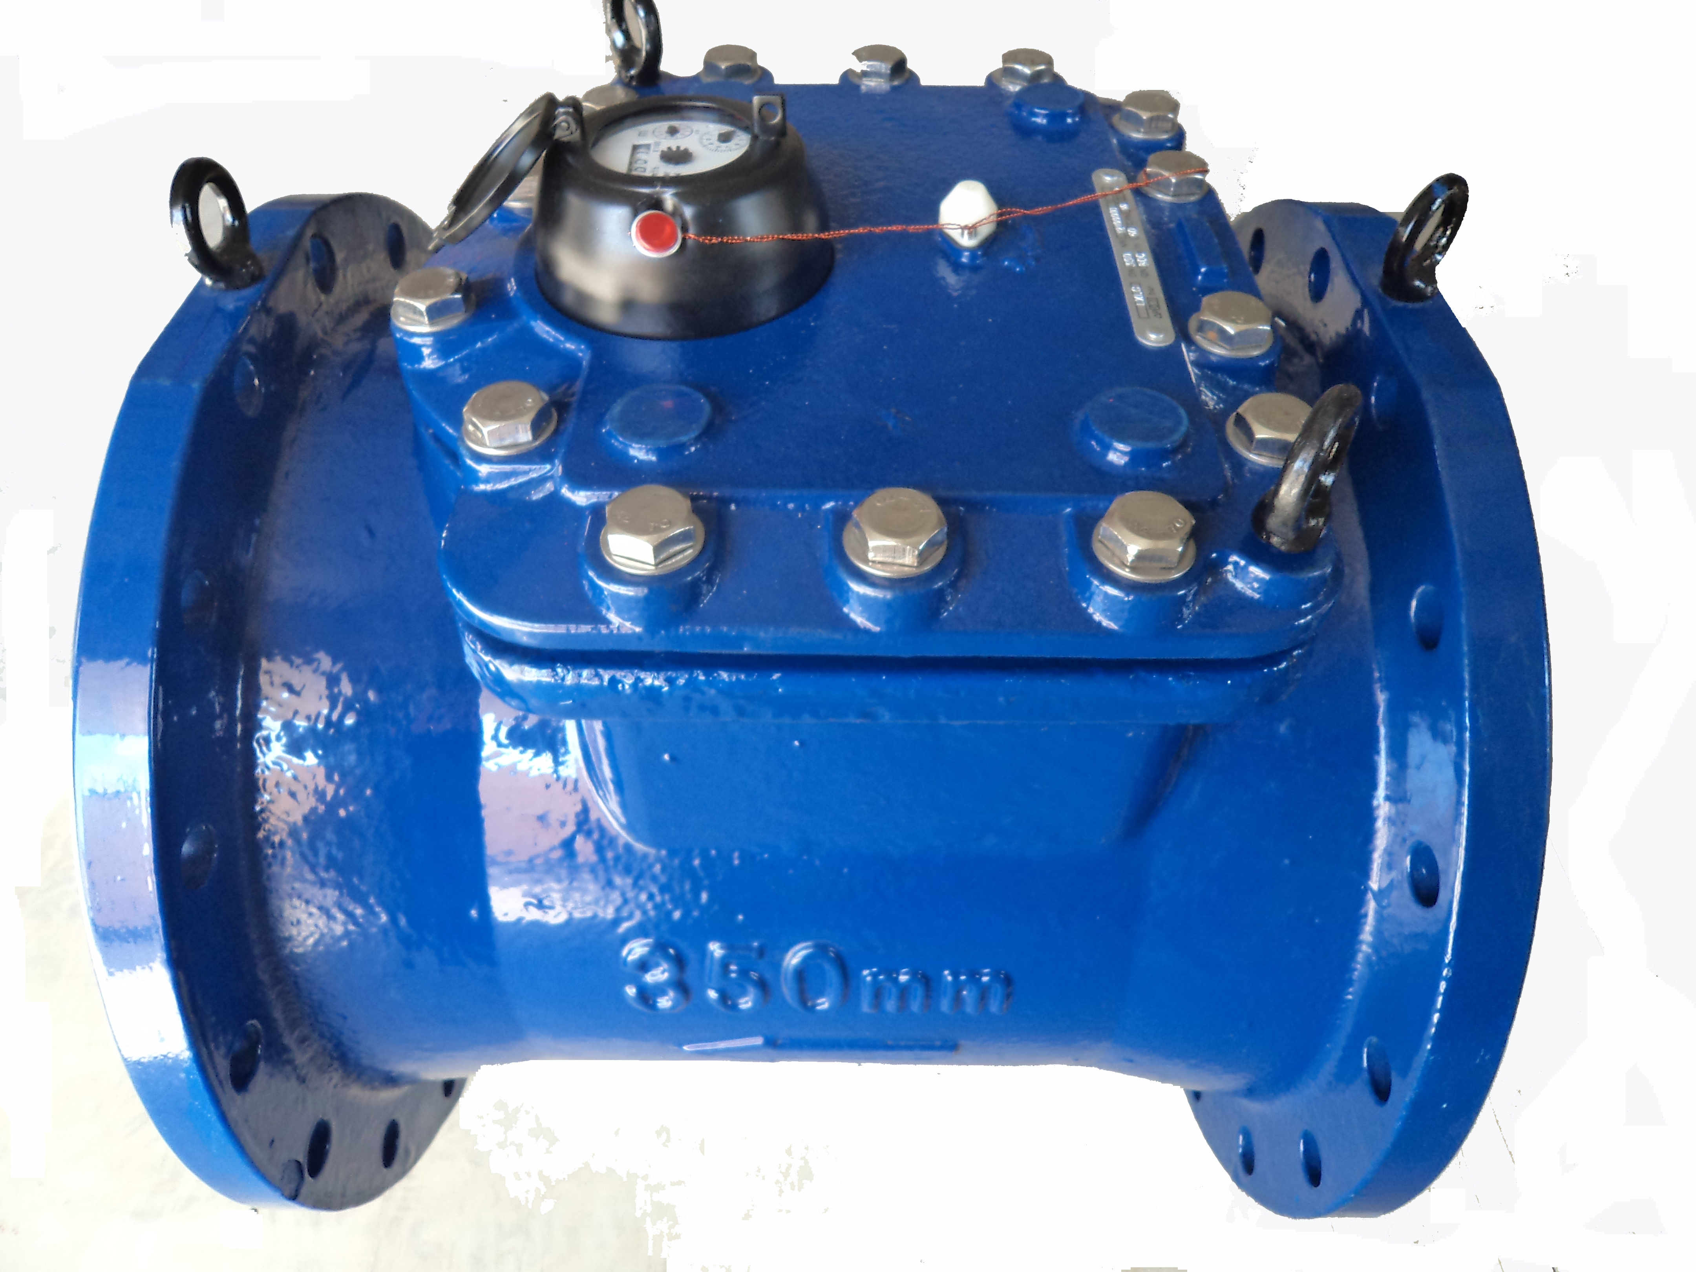

Application:
--Measuring the total volume of cold water passing through the pipeline.
-NOTE:This type of water meter can be used for a reading transmission system as equipped with pluse.
Feature:
-- Dry-dial, Magnetic drive
----Vacuum sealed register ensures the dial keep free from fog and Keep the reading clear in a long term service;
--Removable element unit and strong universality, easy installation and maintenance,
--Measuing high flow rate with low head loss.
-- Remote transmission device can be added upon request,such as Reed Switch or Hall, Pulse Output:100000L/P、10000L/P.
--Technical data conform to international standard ISO 4064.
Working condition
Water temperature: T30 T50
Water pressure class: MAP16 MAP10
Pressure-loss Class: △p63
Accuracy:
(1) From minimum flow-rate(Q₁) inclusive to transitional flow-rate(Q₂) exclusive±5%.
(2) From transitional flow-rate(Q₂) to overload flow-rate(Q₄):±2%;

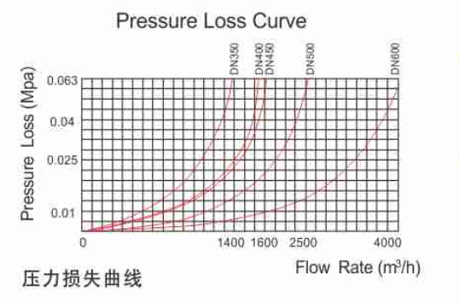

MAIN TECHNICAL SPECIFICATIONS

型号  Type | 公称口径Size | 计量等级Class | 过载流量  Q4 Overload Flow | 常用流量  Q3 Permanent Flow | 分界流量  Q2 Transitional Flow | 最小流量  Q1  Min.Flow |  |  | 最小读数  Min. Reading | 最大读数  Max. Reading
型号  Type | 公称口径Size | 计量等级Class | m³/h |  |  |  |  |  | m³
LXLC-350 | 14〞 | R50 | 1750 | 1400 | 44.8 |  | 28 |  | 0.2 | 999,999,999
LXLC-400 | 16〞 | R50 | 2000 | 1600 | 51.2 |  | 32 |  | 0.2 | 999,999,999
LXLC-450 | 18〞 | R50 | 2000 | 1600 | 51.2 |  | 32 |  | 0.2 | 999,999,999
LXLC-500 | 20〞 | R50 | 3125 | 2500 | 80 |  | 50 |  | 0.2 | 999,999,999
LXLC-600 | 24〞 | R50 | 5000 | 4000 | 128 |  | 80 | 0.2 |  | 999,999,999

DIMENSIONS
外形尺寸
型号  Type | 公称口径Size |  | 长  Length |  | 高  Height | 连接法兰Connecting flange
 |  |  |  |  |  | φD1 Outside diameter | φD2 Bolt circle diameter | Connecting  Bolts(n-M) | Working pressure (MPa)
型号  Type | mm
LXLC-350 | 14〞 | 500 |  | 590 |  | 505 | 460 | 16-M20 | 1.0
 |  |  |  |  |  | 520 | 470 | 16-M24 | 1.6
LXLC-400 | 16〞 | 600 |  | 660 |  | 565 | 515 | 16-M24 | 1.0
 |  |  |  |  |  | 580 | 525 | 16-M27 | 1.6
LXLC-450 | 18〞 | 600 |  | 700 |  | 615 | 565 | 20-M24 | 1.0
 |  |  |  |  |  | 640 | 585 | 20-M27 | 1.6
LXLC-500 | 20〞 | 800 |  | 760 |  | 670 | 620 | 20-M24 | 1.0
 |  |  |  |  |  | 715 | 650 | 20-M30 | 1.6
LXLC-600 | 24〞 | 800 |  | 880 |  | 780 | 725 | 20-M27 | 1.0
 |  |  |  |  |  | 840 | 770 | 20-M33 | 1.6
NOTE: The flange dimension conforms to ISO7005-2:1988 standard. Order for products of special requirements is also accepted.
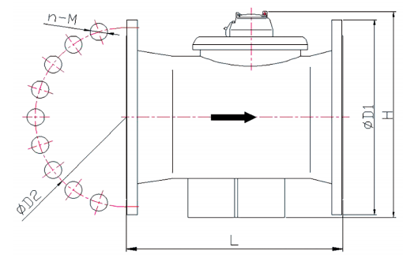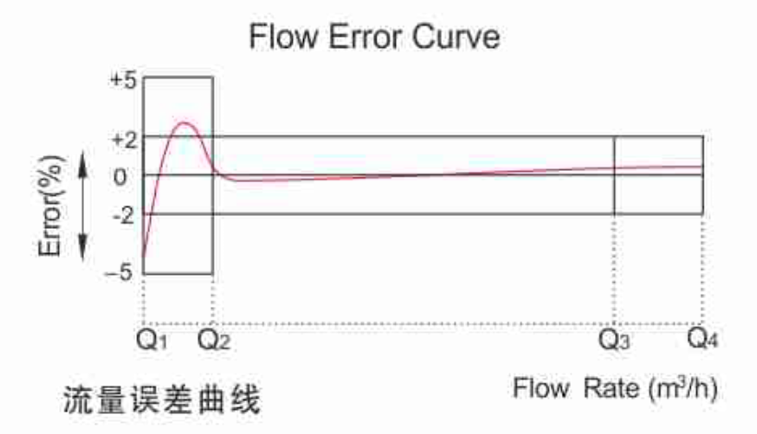
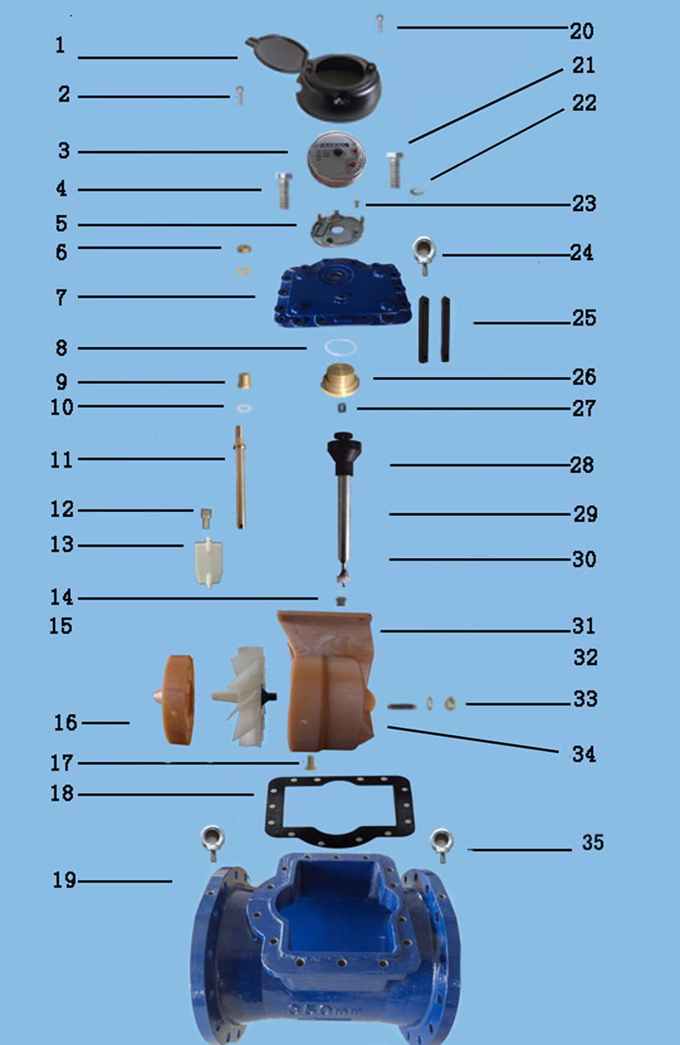
LXLC-350-500 REMOVABLE ELEMENT WOLTMAN WATER METER
Code | Description | Material | QTY
1 | Screw For Sealing | Stainless Steel | 1
2 | Cover With Lid | Assembly | 1
3 | Sealed Register | Assembly | 1
4 | Screw M16×45 for sealing | Stainless Steel | 1
5 | Fixed plate | PPO | 1
6 | Adjusting Nut | Brass | 1
7 | Flange Cover | Cast Iron | 1
8 | O-ring | Silicon Rubber | 1
9 | Bush | Brass | 1
10 | Gasket | Synthetic Rubber | 1
11 | Adjusting Lever | Brass | 1
12 | Connecting Lever | Brass | 1
13 | Adjusting Plate | POM OR MPPO | 1
14 | Support and gear | Brass and pom | 2
15 | Turbine Component | Assembly | 1
16 | Rectifier | ABS OR MPPO | 1
17 | Screw | Brass | 1
18 | O-ring | Synthetic Rubber | 1
19 | Body | Cast Iron | 1
20 | Screw For Sealing | Stainless Steel | 2
21 | Screw For Sealing M16X45 | Stainless Steel | 13
22 | plate | Stainless Steel | 14
23 | Fixing screw | Stainless Steel | 4
24 | rings | Stainless Steel | 2
25 | Support block | Cast Iron | 2
26 | Upper Bearing Plate | Brass | 1
27 | Upper Bearing | Nylon With Graphite | 1
28 | Magnet Component | Component | 1
29 | casing | Stainless Steel | 1
30 | Transmission Shaft | Stainless Steel | 1
31 | Support | Nylon | 1
32 | Turbine Shaft | Tungsten Steel | 1
33 | Screw | Brass | 1
34 | Nut | Brass | 1
35 | rings | Stainless Steel | 2

----------------------------------------------------------------------------------------------------------------------
LIANYUNGANG HYTTEN METER CO.,LTD.
Add:No. 8 Hanguo Industrial Development Zone,Luoyang Village
Dunshang Town,Ganyu District, Lianyungang, Jiangsu, China
Tel: ++86-518-85907891
Fax: ++86-518-85907890 Postal code: 222000
E-mail: hytten@hyttenmeter.com
http://www.hyttenmeter.com www.hyttenwatermeter.com

