Ws 40-200mm
Woltman Vertical Installation type Dry-dial water meter
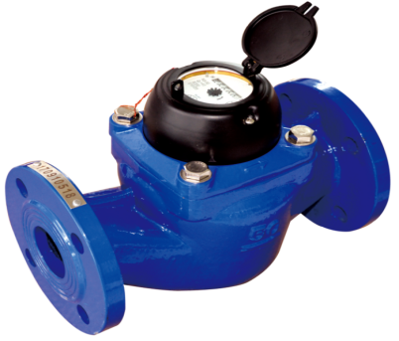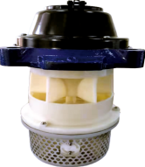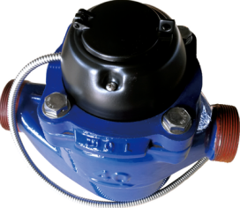
Application:
--Measuring the total volume of cold water passing through the pipeline.
Note: It is a Vertical Woltman water meter for industril and Irrigation application in sizes from 50 to 200mm for cold meter.
Features
--Removable measruing unit,Inner filter,easy manintance.
-- Dry dial register, Magnetic drive,keep clear reading for long time.
-- Low start flow, low pressure loss at high flowrate, better than vane wheel meter.
--Can make Photoelectric direct reading remote transmission and OUTPUT water meter,Remote transmission device can be added upon request,such as Reed Switch or Hall, Pulse Output:1000L/P、100L/P.
--Technical data conform to international standard ISO 4064.
Working condition
Water temperature: T30 T50 T90
Water pressure class: MAP16 MAP10
Pressure-loss Class: △p63
Accuracy:
(1) From minimum flow-rate(Q₁) inclusive to transitional flow-rate(Q₂) exclusive±5%.
(2) From transitional flow-rate(Q₂) to overload flow-rate(Q₄):±2%;
(Hot water meter ±3%)

MAIN TECHNICAL SPECIFICATIONS

TYPE | Size  mm | Permanent flow  Q4 | Overload Flow  Q3 | Q3/Q1 | Q2/Q1 | Transmission  Flow  Q2 | Min Flow  Q1 | Min Reading | Max  Reading
TYPE | Size  mm | (m³/h) |  | Q3/Q1 | Q2/Q1 | m³
WS-40 | 1½" | 50 | 40 | 160 | 1.6 | 0.4 | 0.25 | 0.0005 | 999,999
 |  |  |  |  | 6.3 | 1.58 | 0.25 | 0.0005 | 999,999
WS-50 | 2" | 50 | 40 | 160 | 1.6 | 0.4 | 0.25 | 0.0005 | 999,999
 |  |  |  |  | 6.3 | 1.58 | 0.25 | 0.0005 | 999,999
 |  |  |  | 200 | 1.6 | 0.32 | 0. 2 | 0.0005 | 999,999
 |  |  |  |  | 6.3 | 1.26 | 0. 2 | 0.0005 | 999,999
WS-65 | 2½" | 50 | 40 | 160 | 1.6 | 0.4 | 0.25 | 0.0005 | 999,999
 |  |  |  |  | 6.3 | 1.58 | 0.25 | 0.0005 | 999,999
 |  |  |  | 200 | 1.6 | 0. 32 | 0.2 | 0.0005 | 999,999
 |  |  |  |  | 6.3 | 1.26 | 0.2 | 0.0005 | 999,999
WS-80 | 3" | 79 | 63 | 160 | 1.6 | 0. 63 | 0. 39 | 0.0005 | 999,999
 |  |  |  |  | 6.3 | 2.48 | 0. 39 | 0.0005 | 999,999
 |  |  |  | 200 | 1.6 | 0.5 | 0. 32 | 0.0005 | 999,999
 |  |  |  |  | 6.3 | 2 | 0. 32 | 0.0005 | 999,999
WS-100 | 4" | 125 | 100 | 160 | 1.6 | 1 | 0. 63 | 0.0005 | 999,999
 |  |  |  |  | 6.3 | 3.94 | 0. 63 | 0.0005 | 999,999
 |  |  |  | 200 | 1.6 | 0.8 | 0.5 | 0.0005 | 999,999
 |  |  |  |  | 6.3 | 3. 15 | 0.5 | 0.0005 | 999,999
WS-150 | 5" | 312 | 250 | 160 | 1.6 | 2.5 | 1.56 | 0.0005 | 999,999
 |  |  |  |  | 6.3 | 9.8 | 1.56 | 0.0005 | 999,999
 |  |  |  | 200 | 1.6 | 2 | 1.25 | 0.0005 | 999,999
 |  |  |  |  | 6.3 | 7.9 | 1.25 | 0.0005 | 999,999
WS-200 | 6" | 500 | 400 | 160 | 1.6 | 4 | 2.5 | 0.0005 | 999,999
 |  |  |  |  | 6.3 | 15.8 | 2.5 | 0.0005 | 999,999
 |  |  |  | 200 | 1.6 | 3.2 | 2 | 0.0005 | 999,999
 |  |  |  |  | 6.3 | 12.6 | 2 | 0.0005 | 999,999

DIMENSION
Type  DN  (mm) | Length  L  (mm) | Height  H  (mm) | CONNECTING flange
Type  DN  (mm) | Length  L  (mm) | Height  H  (mm) | Outside Diameter  D | Bolt circle diameter  D1 (mn) | Connecting Bolts  (n-M)
WS-40 | 245 | 280 | -- | -- | R1½"(螺纹连接）
WS-50 | 280 | 280 | 165 | 125 | 4XM16
WS-65 | 280 | 280 | 185 | 145 | 4XM16
WS-80 | 370 | 300 | 200 | 160 | 8XM16
WS-100 | 370 | 305 | 220 | 180 | 8XM16
WS-150 | 500 | 500 | 285 | 240 | 8XM20
WS-200 | 500 | 515 | 340 | 295 | 8XM20

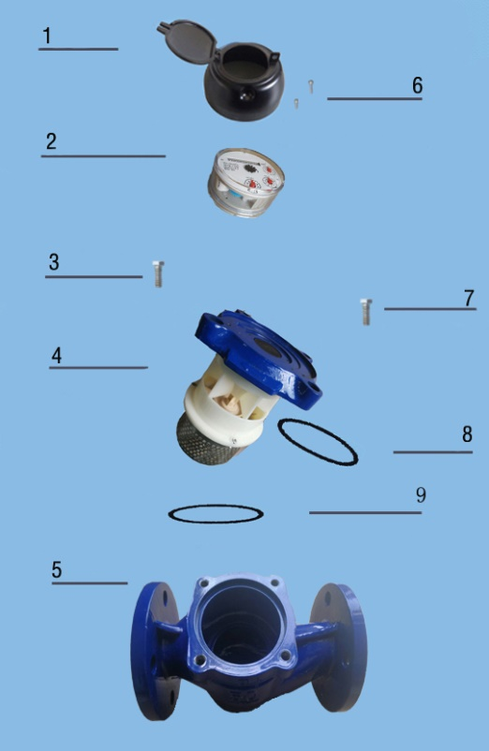
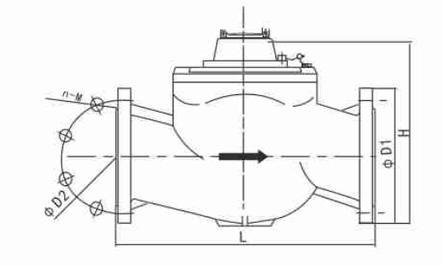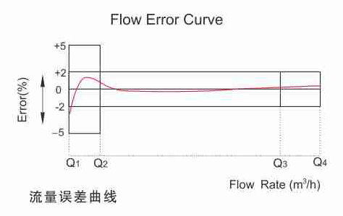
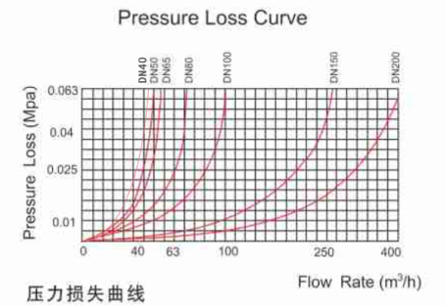

WS-40～200 Woltman Vertical InstallationType Dry-Dial Water Meter
Code | Description | Material | QTY
1 | Cover with lid | Assembly | 1
2 | Sealed Register | Assembly | 1
3 | Screw | Stainless Steel | 1
4 | Mechanism | Assembly | 1
5 | Body | Grey cast iron | 1
6 | Screw | Stainless Steel | 2
7 | Screw | Stainless Steel | 1
8 | O-ring | Rubber | 1
9 | O-ring | Rubber | 1

LIANYUNGANG HYTTEN METER CO.,LTD.
Address: NO.8 Hanguo Industrial Development Zone,Luoyang village,Dunshang Town,Ganyu District, Lianyungang City.
Tel：0518-85907891 Fax：0518-85907892
Http：//www. hyttenmeter.com E-mail：hytten@hyttenmeter.com

