NB-IoT物联网水表
NB-IoT Water meter

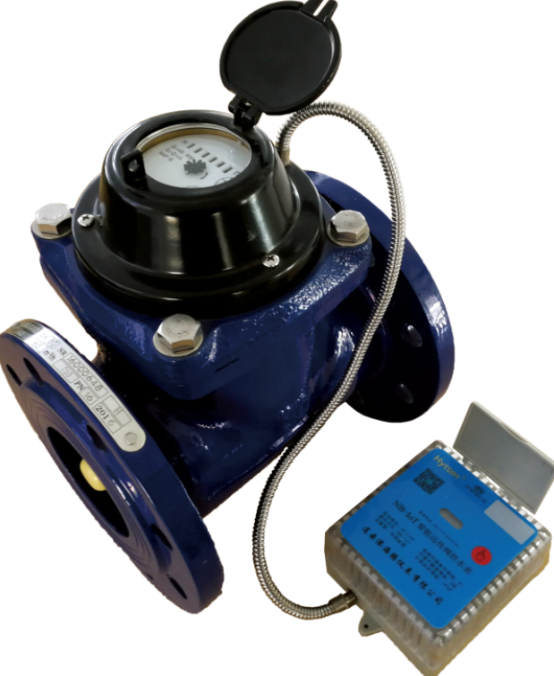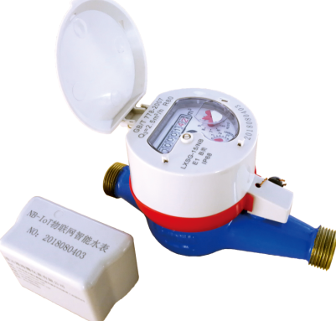
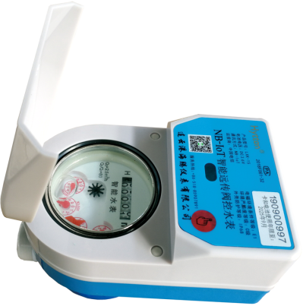
1 概述 Summary
1.1 简介 Brief Introduction
物联网水表是指应用了移动网络的远传水表，是最新一代远传水表。它显著的特点之一是它的综合成本很低，特别是安装成本，就跟普通机械水表一样，无需穿孔、布线等现场操作，只要把表装在管道上就可以运行了。所有的调试完全在计算机终端完成，全国推广起来简便易行。物联网水表的使用成本也低于传统智能表。在旧的模式下,数据传输需要数据线、手持机、中继器和集中器4个环节，任何环节出问题都会导致批量性错误，其安装维护要求较高。而物联网水表删繁就简，从表端到云端无任何中间环节，即使出现问题也仅是个表问题，维护和运行成本可降至最低。
此系列水表本公司采用模块化机电分离模式：机械计量部分与数据传输部分完全模块化，可以任意安装组合。
This kind of IoT water meter is the latest generation of remote water meter that application of mobile network remote water meter,.One of its remarkable characteristics is that its comprehensive cost is very low, especially the installation cost, just like the ordinary mechanism water meter, no need for perforation, wiring and other field operations, only install on the pipeline can run. All the debugging is completely completed in the computer terminal, and it is easy to popularize it. The cost of using Internet of things water meters is also lower than that of traditional smart meters. In the old mode, data transmission needs four links: data line, handheld machine, repeater and concentrator. Any problem in any link will lead to batch error, and its installation and maintenance requirements are high. However, the water meter of the Internet of things is simple, there is no intermediate link from the water meter end to the cloud, even if there is a problem, it is only a water meter problem, and the cost of maintenance and operation can be reduced to the lowest.
This series of water meters is in the form of a modular electromechanical separation mode: the mechanical metering section and the data transmission section are completely modular, and any combination can be installed.
2 功能介绍 Function
2.1 主要功能说明 The main function introduction
 | 功能名称 Name |  | 功能简述 Resume | 功能参数 Parameter
1 | 计量 Measurement |  | 采用有磁或无磁传感器计量信号  Use of magnetic or Non-magnetic sensor measurement signals
2 | 表号管理  The management of water meter No. |  | 每块表唯一的识别号  Unique identification number for each water meter. | 可供用户使用8位表号  Available for users to use 8-bit numbers
3 | 初始化  Initialization |  | 将仪表的计量数据清零。  Zeroing the metering data of the instrument  将所有参数恢复成默认值。  Restore all parameters to default values
4 | 校正时间  Correction Time |  | 无闰年问题，可随时校时。  without a leap year problem, can  be calibrated at any time | 2000年～2100年，  最小可校正到秒。From 2000 to 2100,Min. correctable to seconds
5 | 电池电压检测  Battery voltage detection |  | 电池电压到达下限值时，能做出报警提示。When the battery voltage reaches the lower limit, it can make an alarm prompt.
6 | 远程诊断  Remote diagnosis |  | 正向累计量，反向累计量，剩余金额，当前瞬时流量，电池状态等报警等信息。Forward cumulant, reverse cumulant, residual amount, current instantaneous flow, battery status and other alarm information.
7 | 写NB参数 | NB定点开  NB Fixed Time opening | 在某一时刻开NB电源。  Turn on the NB power at some time | 范围：0点0分～23点59分。  Range:0:0:0-23:59
7 | 写NB参数 | NB间隔开  NB Interval opening | 每间隔一段时间开NB电源。  Turn on the NB power supply every interval | 范围：10分钟～1440分钟。  Range: 10 minutes to 1440 minutes
7 | 写NB参数 | NB定量开  NB Quantitative opening | 每间隔一定用水量开NB电源  Water consumption must be used at every interval to turn on NB power supply | 该功能暂不可用  This function is temporarily unavailable
7 | 写NB参数 | NB故障报警开  Nb fault alarm on | NB表发生系统故障或监测到用水情况异常时开NB电源。Turn on NB power supply when NB Water meter has system failure or monitoring abnormal water use
7 | 写NB参数 | NB超时  NB Overtime | 默认80秒，建议不低于80秒  80 seconds by default, not less than 80 seconds
7 | 写NB参数 | NB传输时段  NB Transmission period | 默认0~24点为工作时段  The default 0 / 24 is working hours
8 | 读模块生产批号  Read module production batch No. |  | 包括模块生产批号，软件版本，软件编译时间，第几次编译等  Including module production batch No, software version, software compilation time, several compilations, etc.
9 | 读参数 Read parameters |  | 随时读出表内参数，包括：程序版本，NB参数，工作模式等  Read out the parameters in the water meter at any time, including: program version, NB parameters, working mode, etc.
2.2 NFC可读数据列表 NFC readable data list
 | 数据名称 Name of Data |  | 功能简述 Resume of Function | 备注 Remarks
1 | 当前底数 Current base No. |  | 同机械数 Same as Mechanism No.
2 | 累计反向水量Cumulative reverse water quantity |  | 反转累积量  Reverse accumulation
3 | 表号 No. |  | 备用 Standby
4 | IP地址 IP address |  | 主IP,备用IP1,备用IP2  Main IP, Standby IP1,Standby IP2
5 | NB上报参数 | NB定点开 NB fixed Time opening | 在某一时刻开NB电源。  Turn on the NB power at some Time
5 | NB上报参数 | NB间隔开  NB Interval opening | 每间隔一段时间开NB电源。  Turn on the NB power supply every interval
5 | NB上报参数 | NB超时 NB Overtime | 默认80秒，建议不低于80秒  80 seconds by default, not less than 80 seconds
5 | NB上报参数 | NB传输时段  NB Transmission period | 默认0~24点为工作时段  The default 0 / 24 is working hours
6 | 水表状态  Water meter status |  | 电池电压，故障状态等信息  Battery voltage, fault status, etc. Information
7 | NB相关信息  NB related information |  | ICCID
7 |  |  | SIM
7 |  |  | IMSI
7 |  |  | IMEI
8 | 每日零点数据  Daily 0:00 data |  | 底数，反向水量，水表状态等  Base No., reverse water quantity, water meter status, etc.
2.3 NFC可更改数据列表 NFC can change the data list
 | 数据名称 Name of Data |  | 功能简述 Resume of Function | 备注 Remarks
1 | 当前底数 Current base No. |  | 同机械数 Same as mechanism No.
2 | 累计反向水量 Cumulative reverse water Value |  | 反转累积量  Reverse accumulation
3 | 表号 Water meter No. |  | 备用 Standby
4 | IP地址 IP Address |  | 主IP,备用IP1,备用IP2  Main IP, Standby IP1,Standby IP2
5 | NB上报参数 | NB定点开  NB fixed Time opening | 在某一时刻开NB电源。  Turn on the NB power at some Time
5 | NB上报参数 | NB间隔开  NB Interval opening | 每间隔一段时间开NB电源。  Turn on the NB power supply every interval
5 | NB上报参数 | NB超时  NB Overtime | 默认80秒，建议不低于80秒  80 seconds by default, not less than 80 seconds
5 | NB上报参数 | NB传输时段  NB Transmission period | 默认0~24点为工作时段  The default 0 / 24 is working hours
2.4 其它说明：The other Instruction
2.4.1 数据交互方式：The data interaction mode
可以通过TTL方式进行初始化清零，远程诊断，设置NB参数，校时等操作，也可以通过NB网络设置参数。
You can initialize zero clearance, remote diagnosis, set NB parameters, time correction and so on through TTL , or you can set parameters through NB network.
2.4.2初始化操作影响参数列表
List of parameters affected by initialization operations
 | 参数 Parameters |  | 初始化后状态 The status after initialization | 备注 Remarks
1 | 预付费模式 Prepaid mode |  | 未激活 Not activated
2 | 正反向累计水量  positive and negative cumulative water volume |  | 0
3 | 时间 Time |  | 恢复成程序编译时间  Restore to program compilation time
4 | NB参数 | 定点开NB Fixed time open NB | 关闭  Close
4 | NB参数 | 传输时段 Transmission period | 0点~24点  0: 00 to 24:00
4 | NB参数 | 传输间隔 Transmission interval | 1440分钟  1440 Mins
4 | NB参数 | 传输超时时长  Transmission timeout | 80秒  80 Secs.
3．技术指标 Technical Index.
 | 名称 Name | 参数 Parameters |  |  |  | 备注 Remarks
 | 名称 Name | 最小 Min. | 典型  Typical | 最大  Max. | 单位  Unit | 备注 Remarks
1 | 网络制式 Network system | NB_IOT
2 | 近距离通信方式  Short- distance communication mode | NFC
3 | 静态工作电流 Static working current |  | 10 | 15 | uA
4 | 通信工作电流  Communication working current |  |  | 200 | mA
5 | 电池 Battery |  | +3.6 |  | V
6 | 电池欠压点  Battery under-voltage point | 3.2 |  | 3.3 | V
7 | 正常上线电压  Normal on-line voltage | 3.1 |  |  | V
8 | NB每天时通信次数 NB No of times of communications per day |  |  | 1 | 次 Times
9 | 内置电池使用寿命  Service life of built-in battery | 6 |  | 10 | 年 year | ER26500
10 | 频率 Frequency |  | 850 |  | MHZ
11 | 发射功率 Transmitting power |  |  | 23 | dBm
12 | 灵敏度 Sensitivity |  |  | -129 | dBm
13 | 工作温度 Working temperature | -10 |  | 50 | ℃
14 | 存储温度 Storage temperature | -20 |  | 60 | ℃
15 | 湿度 Humidity |  | 85%
注：基于不同的信号覆盖等级，单次上报数据的耗电量不同。
Note:The power consumption of single reported data is different based on different signal coverage levels
 | 信号覆盖等级  Signal coverage level | 单次耗电量  Single power consumption |  |  |  | 每年耗电量  Annual electricity consumption  (mAH) | 备注  Remarks
 | 信号覆盖等级  Signal coverage level | 最小Min. | 平均  Average | 最大  Max. | 单位  Unit | 每年耗电量  Annual electricity consumption  (mAH) | 备注  Remarks
1 | 等级Grade 0 | 247 | 270 | 292 | uAH | 90~107
2 | 等级Grade 1 | 300 | 1400 | 2527 | uAH | 110~922
3 | 等级Grade 2 | 1278 | 2200 | 5007 | uAH | 466~1825
4、典型应用 Application

