DN15-50 RF Card Smart Water Meter
DN15-50射频卡智能水表
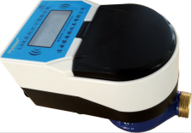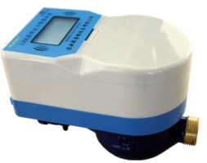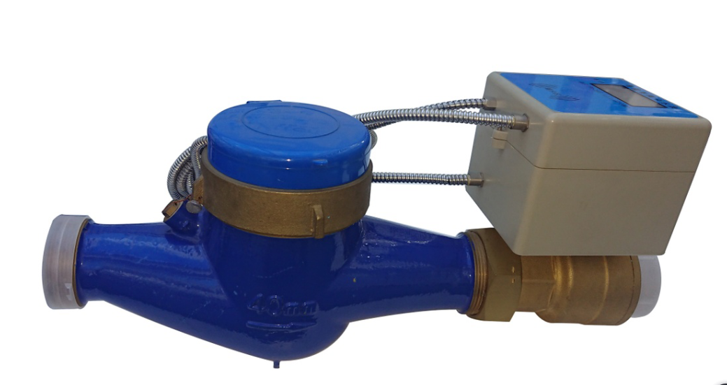
Application:
--Measuring the total volume of cold(hot) water passing through the pipeline.
-NOTE:This type of water meter can be used for a reading transmission system as equipped with a built-in-sensor
Feature:
--RF water meter uses pre-paid way to achieve new management mode which is “Pay first, then use”
--Show the different price level of the water, one card can used for several meters
--Double reading dispay: mechanical and electronic
--Unique battery protection
--Stable performance, wide application
--Low power consumption and long working life
--Vacuum sealed electronic parts IP68
--Anti-Magnetic function
Working condition:
Water temperature: T30 T50 T90
Water pressure class: MAP16 MAP10
Installation environment: Class B
Electromagnetic environment: Class E₁
Accurancy:
(1) From minimum flow-rate(Q₁) inclusive to transitional flow-rate(Q₂) exclusive±5%.
(2) From transitional flow-rate(Q₂) to overload flow-rate(Q₄):±2%(Hot water meter:; ±3%)
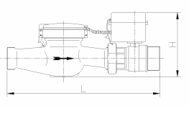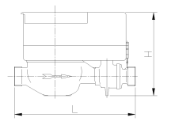

MAIN TECHNICAL SPECIFICATIONS

Type | Size | Class | Q₄  Overload Flow | Q₃  Permanent Flow | Q2_{t}  Transitional Flow | Q₁  Minimum  Flow | Min.  Reading | Max.  Reading
Type | Size | Class | m³/h |  |  |  | m³
LXSG-15/RF | ½" | R80  (R100) | 3.125 | 2.5 | 0.05 | 0.03125 | 0.00005 | 99,999
LXSG-20/RF | ¾" | R80  (R100) | 5 | 4 | 0.08 | 00.05 | 0.00005 | 99,999
LXSG-25/RF | 1" | R80  (R100) | 7.875 | 6.3 | 0.126 | 0.07875 | 0.00005 | 99,999
LXSG-32/RF | 1¼" | R80  (R100) | 12.5 | 10 | 0.2 | 0.125 | 0.00005 | 99,999
LXSG-40/RF | 1½" | R80  (R100) | 20 | 16 | 0.32 | 0.2 | 0.00005 | 99,999
LXSG-50/RF | 2" | R80  (R100) | 31.25 | 25 | 0.5 | 0.3125 | 0.00005 | 99,999

DIMENSIONS
Type | Size | L  Length | H Height | B  Width | Connecting Thread
Type | mm |  |  |  | D | d
LXSG-15/RF | ½" | 165 | 120 | 86 | G3/4 | R1/2
LXSG-20/RF | ¾" | 195 | 120 | 90 | G1 | R3/4
LXSG-25/RF | 1" | 225 | 120 | 85 | G1¹/₄ | R1
LXSG-32/RF | 1¼" | 328 | 210 | 99 | G1¹/₂ | R1¹/₄
LXSG-40/RF | 1½" | 357 | 226 | 119 | G2 | R1¹/₂
LXSG-50/RF | 2" | 406 | 259 | 143 | G2¹/₂ | R2

LIANYUNGANG HYTTEN METER CO.,LTD.
Add:No. 8 Hanguo Industrial Development Zone,Luoyang Village
Dunshang Town,Ganyu District, Lianyungang, Jiangsu, China
Tel: ++86-518-85907891
Fax: ++86-518-85907892 Postal code: 222000
E-mail: hytten@hyttenmeter.com
http://www.hyttenmeter.com www.hyttenwatermeter.com

