LXSG-15-50/IT LXLC-50-300/IT GPRS IOT Remote Transmission(Pre-paid Valve Control)Water meter.
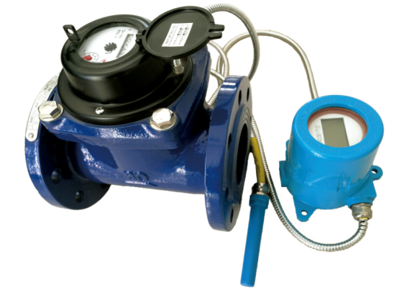
Application:
--Measuring the total volume of cold(hot) water passing through the pipeline.
Feature
--Reading data through long distance wireless communication to avoid disturb residents.
--Effectively solve long time span by manual read data, And unable to read data problems at the same time to facilitate timely statistics of leakage.
--The data can be readed at any time, monitoring water data in real time and managing water efficiently.
--Remote monitoring function,convenient maintenance management.
--Ladder-like wate price.
--Use with valve, can realize prepaid,remote valve control.
--Urban network, realize intelligent water affairs.
--Complete in specifications:DN15-300mm
Working condition:
Water temperature: T30 T50
Water pressure class: MAP16 MAP10
Pressure-loss Class: △p63
Installation environment: Class B
Electromagnetic environment: Class E₁
Accurancy:
(1) From minimum flow-rate(Q₁) inclusive to transitional flow-rate(Q₂) exclusive±5%.
(2) From transitional flow-rate(Q₂) to overload flow-rate(Q₄):±2%（Hot water meter: ±3%）

Technology Index
 | Name | Parameter |  |  |  | Remarks
 | Name | Min. | Model | Max. | Unit | Remarks
1 | Quiescen working current |  | 6 | 10 | uA
2 | Dynamic working current |  |  | 2 | mA
3 | Bluetooth communication working current |  | 30 |  | mA
4 | GPRS Battery |  | +3.6 |  | V
5 | GPRS low battery point | 2.6 |  | 2.8 | V
6 | GPRS Normal Voltage | 2.5 |  |  | V
7 | GPRS Communication times |  | 1000 |  | Times | Typical value:  Battery Capacity>2.7AH
8 | Operating Temperatuer | -10 |  | 50 | ℃
9 | Storage Temperature | -20 |  | 60 | ℃
10 | Humidity |  | 85%
11 | Display time | 19 |  | 21 | S
13 | Input Pulse width |  | 50 |  | ms
14 | Bluebooth Baud Rate |  | 9600 |  | Bps
15 | Motor Locked-rotor Current | 160 | 170 | 190 | mA
16 | Waitting time when Motor drive overtime |  | 30 |  | S
17 | Resistance of reed swith open circuit | 1 | ∞ |  | MΩ | Reed swith base on basic water meter
18 | Effective Response time for Reed swith | 0.1 |  |  | S
18 | Suit for Hall Singal

LIANYUNGANG HYTTEN METER CO.,LTD.
Address: NO.8 Hanguo Industrial Development Zone,Luoyang village,Dunshang Town,Ganyu District, Lianyungang City.
Tel：0518-85907891 Fax：0518-85907892
Http：//www. hyttenmeter.com E-mail：hytten@hyttenmeter.com

