DN32-50mm DQF电动球阀
DQF Series DN32-50mm Electic Ball Valve
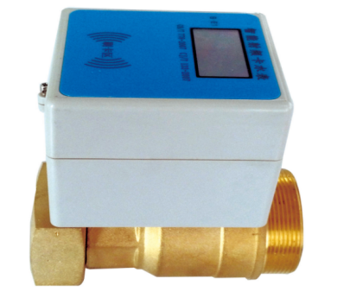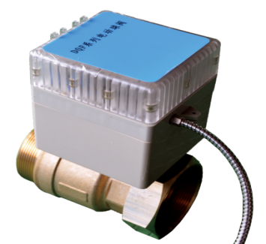

Application
Used for control the swith of water in the pipiline.
Note
The other connection ways will be made in further.
Feature
- Adopting Thread connection to connect with Romote Transmission convenient Installation.
- Actuators was sealed & installed Seperately,convenient for assembly & Maintenance.
- Control box and the valve body can be installed as monolithic or split type.
- Control box and Split type install individually on position tha easy to operate swiping card.
- The actuator rotate in forward and reversal direction by 90℃ to control the on-off swith of valve.
- Control install coil and moduless through full seal.
Working condition
- Use for clean tap water pipe, not suit for liquid that containing impurities and corrosive
- Water meter and the ball valve should avoid freezing,flooding,sunlight exposure and other bad environment.
- Actuator power supply by DC3.6V Lithium batteries.
- Operating temperature:0-90℃
- Water pressure:≤1.0MP
- The ball valve should not be blocked.
DIMENSION
Type | Size | Dimension |  |  |  |  | Conecting Thread
Type | Size | L | L1 | H | h | B | R | D
DN32 | 1¼" | 101 | 113 | 158 | 120 | 98 | R1 1/2 | G1 1/2
DN40 | 1½" | 110 | 122 | 178 | 140 | 98 | R2 | G2
DN50 | 2" | 124 | 143 | 198 | 160 | 98 | R2 1/2 | G2 1/2
MAIN THCHNICAL SPECIFICATIONS
Type | Size | Current parameter |  |  | Valve swiching time
Type | Size | No-load current | Mean load  current | Max.load current | Valve swiching time
DN32 | 1¼" | 25 | 40(10 m³/h) | 75(10 m³/h) | 20-25
DN40 | 1½" | 45 | 60(16 m³/h) | 110(16m³/h) | 50-55
DN50 | 2" | 46 | 65(25 m³/h) | 120(25 m³/h) | 50-55

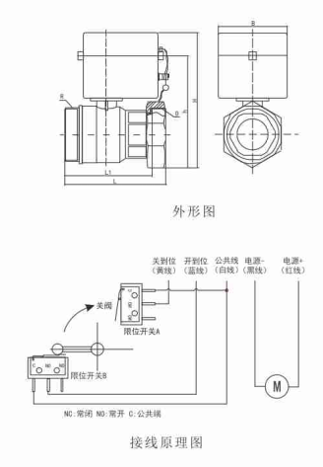

LIANYUNGANG HYTTEN METER CO.,LTD.
Add:No. 8 Hanguo Industrial Development Zone,Luoyang Village
Dunshang Town,Ganyu District, Lianyungang, Jiangsu, China
Tel: ++86-518-85907891
Fax: ++86-518-85907892 Postal code: 222000
E-mail: hytten@hyttenmeter.com
http://www.hyttenmeter.com www.hyttenwatermeter.com

