LXLC-50-300/ZD
Photoelectric direct reading Water Meter

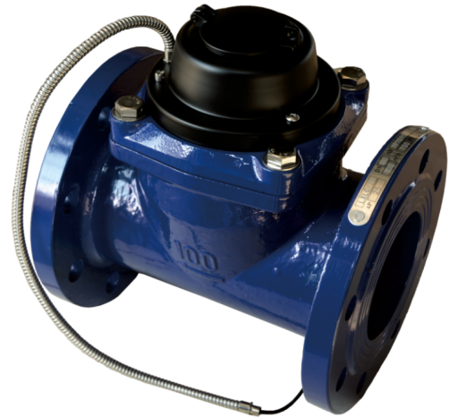
Application:
--Measuring the total volume of cold(hot) water passing through the pipeline.
-NOTE:This type of water meter can be used for a reading transmission system as equipped with a built-in-sensor
Feature:
--Reading data directly, realizes“zero”error basiclly
--Low power design.
--The intelligent electronic unit is completely sealed in the register to effectively avoid the erosion of external water and moisture.
--Meet electromagnetic compatibility design requirement for EMC,ESD,EMI etc electronic products.
--The fault diagnosis shutdown technology is used to guarantee the safety of the whole network.
--Provide M-BUS transmission.
Working condition:
Water temperature: T30 T50 T90
Water pressure class: MAP16 MAP10
Pressure-loss Class: △p63
Installation environment: Class B
Electromagnetic environment: Class E₁
Accurancy:
(1) From minimum flow-rate(Q₁) inclusive to transitional flow-rate(Q₂) exclusive±5%.
(2) From transitional flow-rate(Q₂) to overload flow-rate(Q₄):±2%;

Technical parameters
序号 | Communication mode | RS-485 | MBUS
1 | working voltage | 9V～15V | 24V～42V
2 | static current | ≤1mA | ≤2mA
3 | wording current | ≤5mA | ≤10mA
4 | Communication protocol | DL/T645、CJ/T 188（or customer requirements）
5 | Communication rate | 1200/2400Baud

MAIN TECHNICAL SPECIFICATIONS(R50/80) LXLC
Type | Size | Class | Overload Flow | Permanent Flow | Transitional Flow | Q_{min} Min. Flow | Min. Reading | Max. Reading
Type | Size | Class | m³/h |  |  |  | m³
LXLC-50/ZD | 2" | R50  (R80) | 31.25 | 25 | 0.8 | 0.5 | 0.0005 | 999,999
LXLC-65/ZD | 2½" | R50  (R80) | 50 | 40 | 1.28 | 0.8 | 0.0005 | 999,999
LXLC-80/ZD | 3" | R50  (R80) | 78.75 | 63 | 2 | 1.26 | 0.002 | 999,999
LXLC-100/ZD | 4" | R50  (R80) | 125 | 100 | 3.2 | 2 | 0.002 | 999,999
LXLC-125/ZD | 5" | R50  (R80) | 200 | 160 | 5.12 | 3.2 | 0.002 | 999,999
LXLC-150/ZD | 6" | R50  (R80) | 312.5 | 250 | 8 | 5 | 0.002 | 999,999
LXLC-200/ZD | 8" | R50  (R80) | 500 | 400 | 12.8 | 8 | 0.002 | 999,999
LXLC-250/ZD | 10" | R50  (R80) | 787.5 | 630 | 20.16 | 12.6 | 0.02 | 999,999
LXLC-300/ZD | 12" | R50  (R80) | 1250 | 1000 | 32 | 20 | 0.02 | 9,999,999

MAIN TECHNICAL SPECIFICATIONS(R20/25) WI
Type | Size | Class | Overload Flow | Permanent Flow | Transitional Flow | Q_{min} Min. Flow | Min. Reading | Max. Reading
Type | Size | Class | m³/h |  |  |  | m³
LXXG-50/ZD | 2" | R20  (R25) | 31.25 | 25 | 5 | 1.25 | 0. 002 | 999,999
LXXG-65/ZD | 2½" | R20  (R25) | 50 | 40 | 8 | 2 | 0.002 | 999,999
LXXG-80/ZD | 3" | R20  (R25) | 78.75 | 63 | 12.6 | 3.15 | 0.002 | 999,999
LXXG-100/ZD | 4" | R20  (R25) | 125 | 100 | 20 | 5 | 0.002 | 999,999
LXXG-125/ZD | 5" | R20  (R25) | 200 | 160 | 32 | 8 | 0.002 | 999,999
LXXG-150/ZD | 6" | R20  (R25) | 312.5 | 250 | 50 | 12.5 | 0.002 | 999,999
LXXG-200/ZD | 8" | R20  (R25) | 500 | 400 | 80 | 20 | 0.002 | 999,999
LXXG-250/ZD | 10" | R20  (R25) | 787.5 | 630 | 126 | 31.5 | 0.02 | 999,999
LXXG-300/ZD | 12" | R20  (R25) | 1250 | 1000 | 200 | 50 | 0.02 | 9,999,999

Dimensions
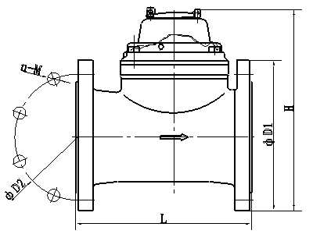

Installation Requirement
- The meter should be installed in horizontal position with the direction of the flow as in dicated by the arrow cast in the meter body with the register face upwards;
- Pipeline must be flushed before installation;
- The meter should be constantly full of water during operation;
- The meter must have 10 diameters straight pipe ahead of the meter and 5 diameters straight pipe after to insure proper flow through the meter.
DIMENSION LXLC
Type | Size |  | L  Length |  | H  Height | Connecting flange
 |  |  |  |  |  | φD1 Outside diameter | φD2 Bolt circle diameter | Connecting Bolts  (n-M)
Type | mm |  |  |  |  | φD1 Outside diameter | φD2 Bolt circle diameter | Connecting Bolts  (n-M)
LXLC-50/ZD | 2" | 200 |  | 214 |  | 165 | 125 | 4-M16
LXLC-65/ZD | 2½" | 200 |  | 224 |  | 185 | 145 | 4-M16
LXLC-80/ZD | 3" | 225 |  | 279 |  | 200 | 160 | 8-M16
LXLC-100/ZD | 4" | 250 |  | 289 |  | 220 | 180 | 8-M16
LXLC-125/ZD | 5" | 250 |  | 299 |  | 250 | 210 | 8-M16
LXLC-150/ZD | 6" | 300 |  | 319 |  | 285 | 240 | 8-M20
LXLC-200/ZD | 8" | 350 |  | 346 |  | 340 | 295 | 8-M20(1.0MPa)
 |  |  |  |  |  |  |  | 12-M20(1.6MPa)
LXLC-250/ZD | 10" | 450 |  | 434 |  | 395 | 350 | 12-M20(1.0MPa)
 |  |  |  |  |  | 405 | 355 | 12-M24(1.6MPa)
LXLC-300/ZD | 12" | 500 |  | 459 |  | 445 | 400 | 12-M20(1.0MPa)
 |  |  |  |  |  | 460 | 410 | 12-M24(1.6MPa)
DIMENSION WI
Type | Size |  | L  Length |  | H  Height | Connecting flange
 |  |  |  |  |  | φD1 Outside diameter | φD2 Bolt circle diameter | Connecting Bolts  (n-M)
Type | mm |  |  |  |  | φD1 Outside diameter | φD2 Bolt circle diameter | Connecting Bolts  (n-M)
LXXG-50/ZD | 2" | 200 |  | 253 |  | 165 | 125 | 4-M16
LXXG-65/ZD | 2½" | 200 |  | 268 |  | 185 | 145 | 4-M16
LXXG-80/ZD | 3" | 225 |  | 284 |  | 200 | 160 | 8-M16
LXXG-100/ZD | 4" | 250 |  | 295 |  | 220 | 180 | 8-M16
LXXG125/ZD | 5" | 250 |  | 310 |  | 250 | 210 | 8-M16
LXXG-150/ZD | 6" | 300 |  | 339 |  | 285 | 240 | 8-M20
LXXG-200/ZD | 8" | 350 |  | 382 |  | 340 | 295 | 8-M20(1.0MPa)
 |  |  |  |  |  |  |  | 12-M20(1.6MPa)
LXXG-250/ZD | 10" | 450 |  | 438 |  | 395 | 350 | 12-M20(1.0MPa)
 |  |  |  |  |  | 405 | 355 | 12-M24(1.6MPa)
LXXG-300/ZD | 12" | 500 |  | 488 |  | 445 | 400 | 12-M20(1.0MPa)
 |  |  |  |  |  | 460 | 410 | 12-M24(1.6MPa)

Lead the definition

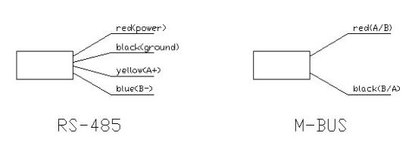
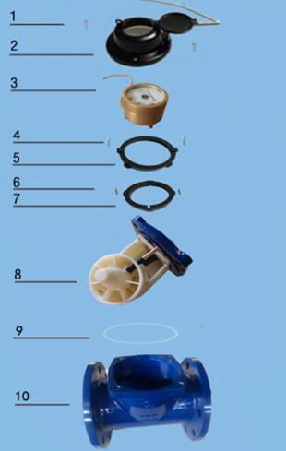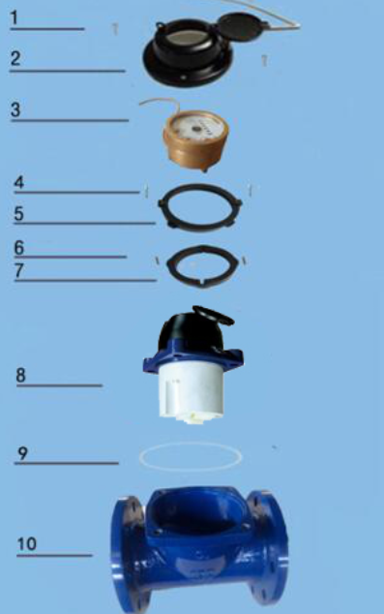
LXLC(WI)-50～300/ZD Photoelectric Direct Reading Water meter
Code | Description | Material | QTY
1 | Screw M5×45 For Sealing | Stainless Steel | 1
2 | Cover with lid | Assembly | 1
3 | Register | Assembly | 1
4 | Screw | Stainless Steel | 1
5 | Circlip | ABS | 4
6 | Fixed clamps | Stainless Steel | 1
7 | Circlip | ABS | 1
8 | Mechanism | Assembly | 3
9 | O-ring | Rubber | 4
10 | Body | Grey cast iron | 1
LIANYUNGANG HYTTEN METER CO.,LTD.
Address: NO.8 Hanguo Industrial Development Zone,Luoyang village,Dunshang Town,Ganyu District, Lianyungang City.
Tel：0518-85907891 Fax：0518-85907892
Http：//www. hyttenmeter.com E-mail：hytten@hyttenmeter.com

