LXSG-15-40/ZD 光电直读
Dry-dial Photoelectric direct reading Water Meter

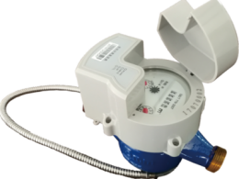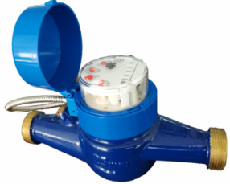
Application:
--Measuring the total volume of cold(hot) water passing through the pipeline.
-NOTE:This type of water meter can be used for a reading transmission system as equipped with a built-in-sensor
Feature:
--Reading data directly, realizes“zero”error basiclly
--Low power design.
--The intelligent electronic unit is completely sealed in the register to effectively avoid the erosion of external water and moisture.
--Meet electromagnetic compatibility design requirement for EMC,ESD,EMI etc electronic products.
--The fault diagnosis shutdown technology is used to guarantee the safety of the whole network.
--Provide M-BUS transmission.
Working condition:
Water temperature: T30 T50
Water pressure class: MAP16 MAP10
Pressure-loss Class: △p63
Installation environment: Class B
Electromagnetic environment: Class E₁
Accurancy:
(1) From minimum flow-rate(Q₁) inclusive to transitional flow-rate(Q₂) exclusive±5%.
(2) From transitional flow-rate(Q₂) to overload flow-rate(Q₄):±2%(Hot water meter:; ±3%)

Technical parameters
序号 | Communication mode | RS-485 | MBUS
1 | working voltage | 9V～15V | 24V～42V
2 | static current | ≤1mA | ≤2mA
3 | wording current | ≤5mA | ≤10mA
4 | Communication protocol | DL/T645、CJ/T 188（or customer requirements）
5 | Communication rate | 1200/2400Baud

MAIN TECHNICAL SPECIFICATIONS(R50/100)
Type | Size | Class | Q_{s} Overload Flow | Q_{p} Permanent Flow | Q_{t} Transitional Flow | Q_{min} Min. Flow
Type | Size | Class | m³/h
LXSG-15/ZD | ½" | R80  (R100) | 31.25 | 2.5 | 0.05 | 0.031
LXSG-20/ZD | ¾" | R80  (R100) | 5 | 4 | 0.08 | 0.05
LXSG-25/ZD | 1" | R80  (R100) | 7.875 | 6.3 | 0.126 | 0.079
LXSG-32/ZD | 1¼" | R80  (R100) | 12.5 | 10 | 0.2 | 0.125
LXSG-40/ZD | 1½" | R80  (R100) | 20 | 16 | 0.32 | 0.2

Dimensions
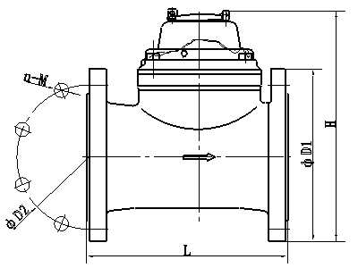

Installation Requirement
- The meter should be installed in horizontal position with the direction of the flow as in dicated by the arrow cast in the meter body with the register face upwards;
- Pipeline must be flushed before installation;
- The meter should be constantly full of water during operation;
- The meter must have 10 diameters straight pipe ahead of the meter and 5 diameters straight pipe after to insure proper flow through the meter.

DIMENSION
Type | Size | L  Length | L1  Length | B  width |  | H  Height | Connecting Thread | Connecting Wire  Metal Hose
Type | mm |  |  |  |  |  | G | m
LXSG-15ZD | ½" | 259 | 165 | 90 | 125 |  | G3/4 | 1.0/0.5
LXSG-20/ZD | ¾" | 299 | 195 | 90 | 125 |  | G1 | 1.0/0.5
LXSG-25/ZD | 1" | 345 | 225 | 94 | 140 |  | G1 1/4 | 1.0/0.5
LXSG-32/ZD | 1¼" | 354 | 230 | 94 | 140 |  | G1 1/2 | 1.0/0.5
LXSG-40/ZD | 1½" | 373 | 245 | 125 | 162 |  | G2 | 1.0/0.5

Lead the definition
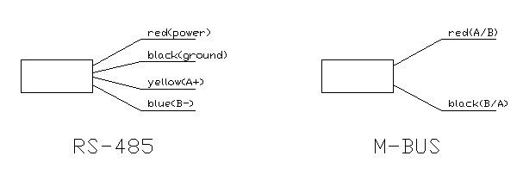
----------------------------------------------------------------------------------------------------------------------
LIANYUNGANG HYTTEN METER CO.,LTD.
Address: NO.8 Hanguo Industrial Development Zone,Luoyang village,Dunshang Town,Ganyu District, Lianyungang City.
Tel：0518-85907891 Fax：0518-85907892
Http：//www. hyttenmeter.com E-mail：hytten@hyttenmeter.com

