LXSG-15~50mm
Wireless Electronical Water Meter
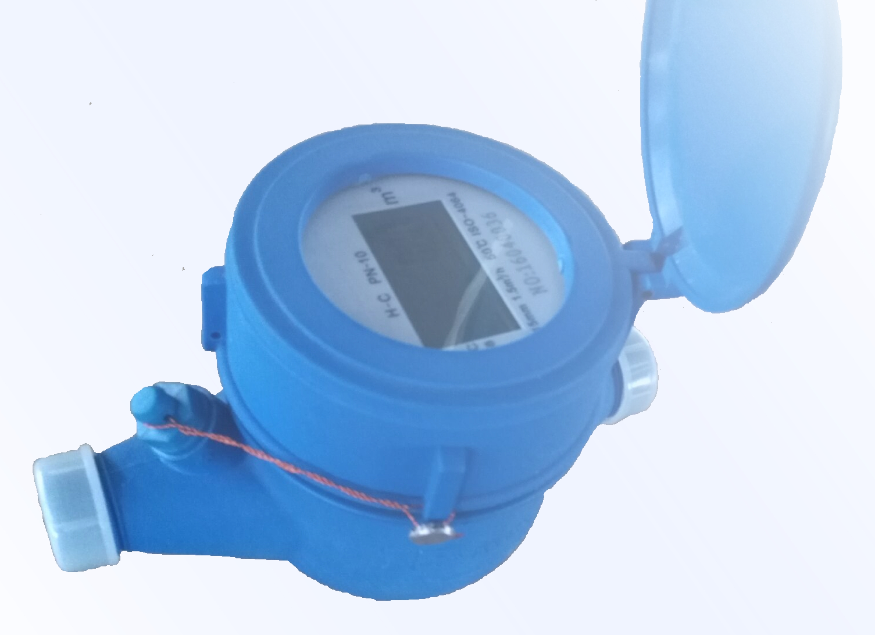
1、Features
- Only one parts can be moving┄turbine, reduce mechanical wear, increased service life;
- Vacuum sealed LCD ensures the dial keep free from fog and frost, Keep the reading clear in a long term service;
- Greatly improve the measurement accuracy, improve the measuring range;
- Piecewise linear optimization of the error curve of the water meter, the measurement accuracy is higher;
- LCD digital direct reading, accurate display measurement information;
- Prompt and accurate measurement of reverse flow;
- Has the instantaneous flow display function;
- Modular design, easy installation and maintenance;
- Automatic calculation of step water price;
- Combined with the valve,can achieve the advance payment and remote control function;
- Automatic storage of historical water data;
- Automatically upload data on specify date;
- Remote diagnostics running status;
- Protection level:IP68.
2、Standards Compliance
- ISO 4064 Class C for horizontal Installation;
- 《Electronic remote-reading water meter》（CJ/T 224-2012）.
3、Working Conditions
- Water temperature：0.1℃~+50℃
- Storage temperature：-10℃~+60℃
- Water pressure:≤1.6 MPa

4、Technical parameters
- working voltage ：DC 3.6V
- current parameters：
- Quiescent current ≤6μA
- Dynamic current ≤9μA
- Communication current≤500μA
- Continuous working time：More than 6 years
- Technical parameters of receiving module
■ Built in TI 16 bit MSP series low power MCU
■ Using Semtech's sx1276 spread spectrum chip
■ Communication distance：1.8Km
■ Output power:+20dBm(Max.)
■ Sensitivity:-147dBm
■ Power Supply:3.0V~3.6V
■ Baud rate：9600bps
■ Communication protocol：188W
■ Communication frequency：868MHz or 433MHz,
Channel spacing 0.5MHz
■ Communication mode：UART

5、MAIN TECHNICAL SPECIFICATIONS
Type | Size | CLASS | Qs | Qn | Qt | Qmin | Minimum Reading | Maximum Reading
Type | Size | CLASS | m³/h |  |  |  | m³
LXSG-15 | ½" | C | 3.0 | 1.5 | 0.0225 | 0.015 | 0.001 | 99,999
LXSG-20 | ¾" | C | 5 | 2.5 | 0.0375 | 0.025 | 0.001 | 99,999
LXSG-25 | 1" | C | 7 | 3.5 | 0.0525 | 0.035 | 0.001 | 99,999
LXSG-32 | 1¼" | C | 12 | 6 | 0.09 | 0.06 | 0.001 | 99,999
LXSG-40 | 1½" | C | 20 | 10 | 0.15 | 0.1 | 0.001 | 99,999
LXSG-50 | 2" | C | 30 | 15 | 0.225 | 0.09 | 0.001 | 99,999
6、Maximum Permissible Error
- From Qmin inclusive up to but excluding Qp is ±5% .
- From Qp inclusive up to and including Qs is ±2% .

- DIMENSIONS
Type | Size | Length | Width | Height | Connecting Thread
Type | Size | mm |  |  | Connecting Thread
LXSG-15 | ½" | 165 | 102 | 121 | G3/4
LXSG-20 | ¾" | 195 | 102 | 122 | G1
LXSG-25 | 1" | 225 | 112 | 135 | G1-1/4
LXSG-32 | 1¼" | 230 | 112 | 136 | G1-1/2
LXSG-40 | 1½" | 245 | 130 | 172 | G2
LXSG-50 | 2" | 300 | 130 | 175 | G2-1/2

8、Installation Requirement
- Installation environment does not affect electromagnetic waves;
- The meter should be installed in horizontal position with the direction of the flow as in dicated by the arrow cast in the meter body with the register face upwards;
- Pipeline must be flushed before installation;
- The meter should be constantly full of water during operation;
- The installation environment should avoid explosed in the sunlight and flooding;
- Master antenna should be installed in the open height;
- Try to avoid the interference of external factors to communication.
- According to the working condition of water supply facilities to determine the type of water meter、 measuring characteristic and the diameter, the expected flow should be adapted to the Qmin to Qn flow. Not only according to the pipe size and don’t give attention to permanent flow to choose water meter.
- Water meters should be avoided under excessive stress caused by pipeline and pipe fittings.
- The water meter should be installed to avoid exposure in the sunshine, freezing, pollution and flooding.The high cold area should avoid to be installed outdoors, If must be installed in outdoor water meter, should adopt sun block, antifreeze measure, The water meter should not be affected by frost crack.
- Should be taken measures to prevent adverse hydraulic conditions (cavitating、surge、 water hammer) to prevent water meters from being damaged.
- Due to not install strictly according to aboved mention, the damage of water meter and its accessories, The installer is responsible for all the damage.
9、The insruction of Order
- The name/type/Diameter of the water meter should be marked on the order.
- Includes two connected pipe & nuts and sealing gaskets for the corresponding calibre in S/C
10、Quality Commitment
The product's quality guarantee period is one year, any reasonable installation,correct use,but there is the interior of damage or malfunction caused by manufacturing (with the exception of freezing), and under the condition of the guarantee seal integrity, the company responsible for repair and exchange.
11、Disclaimer
If the seal was damaged or incomplete or intentionally damaged, the company is not liable;And the company does not undertake other related responsibilities other than water meters (including but not limited to the liability of water metering disputes due to water meter failures or errors)

LIANYUNGANG HYTTEN METER CO.,LTD.
Address: NO.8 Hanguo Industrial Development Zone,Luoyang village,Dunshang Town,Ganyu District, Lianyungang City.
Tel：0518-85907891 Fax：0518-85907892
Http：//www. hyttenmeter.com E-mail：hytten@hyttenmeter.com

