LXSG-15～50mm (Nlyon)
Multi-jet, vane wheel, dry-dial water meter
Application:
-- Measuring the total volume of cold(hot) water passing through the pipeline
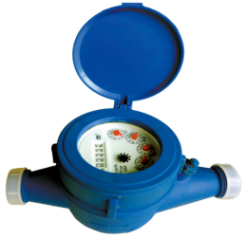
Feature:
--Multi-jet, dry-dial
--Long service life,mechanical drive;
--The cover and its pressure parts was made by water meter special engineering plastics injection with health,environmental protection,ageing resistance,high strengh,large toughness,stable performance,good apperance,easy to connect and light weight.
--Remote transmission device can be added upon request,such as Reed Swith or Hall, Pulse Output:1000L/P、100L/P、10L/P、1L/P.
-- Technical data conform to international standard ISO4064
Working condition:
Water temperature: T30 T50
Water pressure class: MAP16 MAP10
Pressure-loss Class: △p63
Maximum permissible error:
(1) From minimum flow-rate(Q₁) inclusive to transitional flow-rate(Q₂) exclusive±5%.
(2) From transitional flow-rate(Q₂) to overload flow-rate(Q₄):±2%;
(Hot water meter ±3%)

MAIN TECHNICAL SPECIFICATIONS(R80/100)
Type | Size | Class | Q₄  Overload Flow | Q₃  Permanent Flow | Q₂  Transitional Flow | Q₁  Minimum  Flow | Minimum  Reading | Maximum  Reading
Type | Size | Class | m³/h |  |  |  | m³
LXSG-15 | ½" | R80  /100 | 3.125 | 2.5 | 0.05 | 0.03125 | 0.00005 | 99,999
LXSG-20 | ¾" | R80  /100 | 5 | 4 | 0.08 | 0.05 | 0.00005 | 99,999
LXSG-25 | 1" | R80  /100 | 7.875 | 6.3 | 0.126 | 0.07875 | 0.00005 | 99,999
LXSG-32 | 1¼" | R80  /100 | 12.5 | 10 | 0.2 | 0.125 | 0.00005 | 99,999
LXSG-40 | 1½" | R80  /100 | 20 | 16 | 0.32 | 0.2 | 0.00005 | 99,999
LXSG-50 | 2" | R80  /100 | 31.25 | 25 | 0.5 | 0.3125 | 0.00005 | 99,999

DIMENSIONS
Type | Size | L Length | B Width | H Height | Connecting Thread
Type | mm |  |  |  | d | R
LXSG-15 | ½" | 165 | 102 | 121 | G3/4 | R1/2
LXSG-20 | ¾" | 195 | 102 | 122 | G1 | R3/4
LXSG-25 | 1" | 225 | 112 | 135 | G1¹/₄ | R1
LXSG-32 | 1¼" | 230 | 112 | 136 | G1¹/₂ | R1¹/₄
LXSG-40 | 1½" | 230 | 130 | 172 | G2 | R1¹/₂
LXSG-50 | 2" | 280 | 160 | 187.5 | G2 1/2 | G2

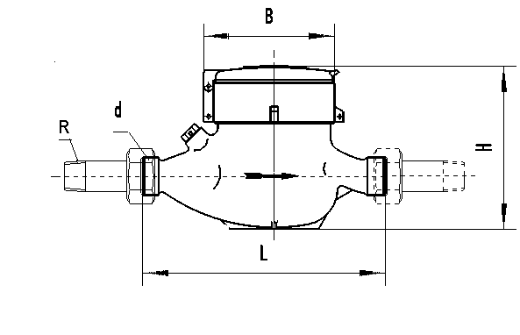

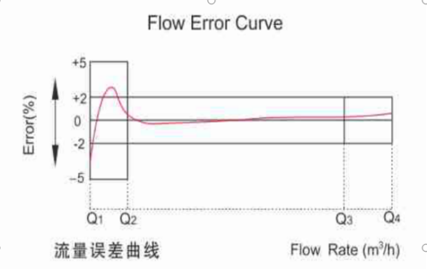

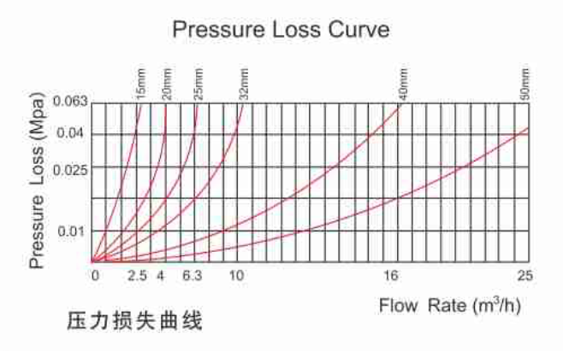

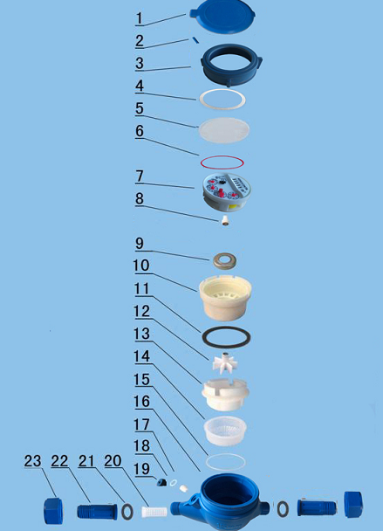

LXSG-15～50 MULTI-JET, VANE WHEEL, DRY-DIAL WATER METER
Code | Description | Material | QTY
1 | Lid | HDPE（ABS） | 1
2 | Hinge Pin | Nylon | 1
3 | Cap | Nylon | 1
4 | Sliding Gasket | PP | 1
5 | Glass | Toughened Glass | 1
6 | O-ring | Silicon Rubber | 1
7 | Register | Assembly | 1
8 | Central Gear | Component | 1
9 | Magnetic Shield Ring | Iron | 1
10 | Magnetic Shield Ring | Iron | 1
11 | Gearing box | ABS Plastic | 1
12 | Tightening Gasket | Rubber | 1
13 | Turbine Component | Component | 1
14 | Measuring Chamber | HIPS | 1
15 | Bottom Strainer | LDPE | 1
16 | Gasket | Silicon Rubber | 1
17 | Body | Plastic | 1
18 | Adjusting Screw | POM | 1
19 | Adjusting Gasket | Nylon | 1
20 | Adjusting Plug | Nylon | 1
21 | Inlet Strainer | PP | 1
22 | Coupling Gasket | Rubber | 2
23 | Coupling Tail Piece | Plastic | 2
24 | Coupling Nut | Plastic | 2

LIANYUNGANG HYTTEN METER CO.,LTD.
Add:No. 8 Hanguo Industrial Development Zone,Luoyang Village
Dunshang Town,Ganyu District, Lianyungang, Jiangsu, China
Tel: ++86-518-85907891
Fax: ++86-518-85907890 Postal code: 222000
E-mail: hytten@hyttenmeter.com
http://www.hyttenmeter.com www.hyttenwatermeter.com

