LXSG-15-20MM Multi-jet Vane Wheel Dry-dial Cold(hot) water meter.
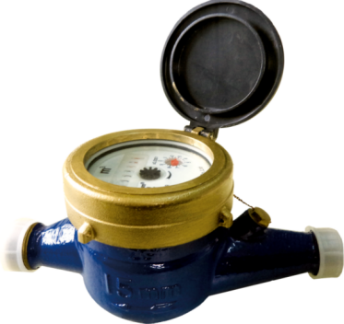
Application:
--Measuring the total volume of cold(hot) water passing through the pipeline.
-NOTE:This type of water meter can be used for a reading transmission system as equipped with a bulit-in-sensor.
Feature:
--Multi-jet, dry-dial; Magnetic drive.
--Vacuum sealed register ensures the dial keep free from fog and frost, Keep the reading clear in a long term service;
--Removable measuring unit,easy installation and maintenance, Anti-magnetic function.
--Brass body,Out-adjust,Small volume and light weight.
-- Technical data conform to international standard ISO4064 Class B
Working condition:
Water temperature: T30 T50 T90
Water pressure class: MAP16 MAP10
Pressure-loss Class: △p63
Maximum permissible error:
(1) From minimum flow-rate(Q₁) inclusive to transitional flow-rate(Q₂) exclusive±5%.
(2) From transitional flow-rate(Q₂) to overload flow-rate(Q₄):±2%;
(Hot water meter ±3%)

MAIN TECHNICAL SPECIFICATIONS(R80/100)
Type | Size | Class | Q₄  Overload Flow | Q₃  Permanent Flow | Q₂  Transitional Flow | Q₁  Minimum  Flow | Minimum  Reading | Maximum  Reading
Type | Size | Class | m³/h |  |  |  | m³
LXSG-15 | ½" | R80  (R100) | 3.125 | 2.5 | 0.05 | 0.03125 | 0.00005 | 99,999
LXSG-20 | ¾" | R80  (R100) | 5 | 4 | 0.08 | 0.05 | 0.00005 | 99,999

DIMENSIONS
Type | Size | L Length | B Width | H Height | Connecting Thread
Type | mm |  |  |  | d
LXSG-15m | ½" | 165 | 89 | 98 | G3/4
LXSG-20m | ¾" | 190 | 89 | 98 | G1

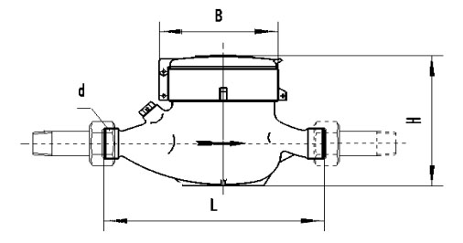
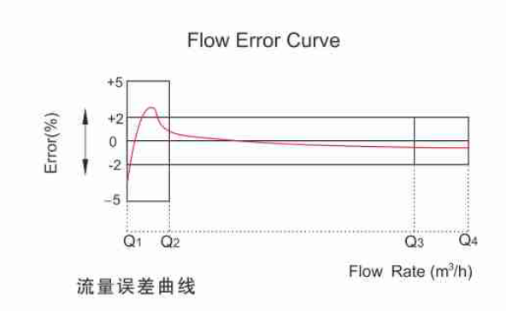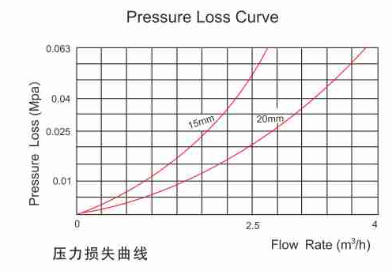

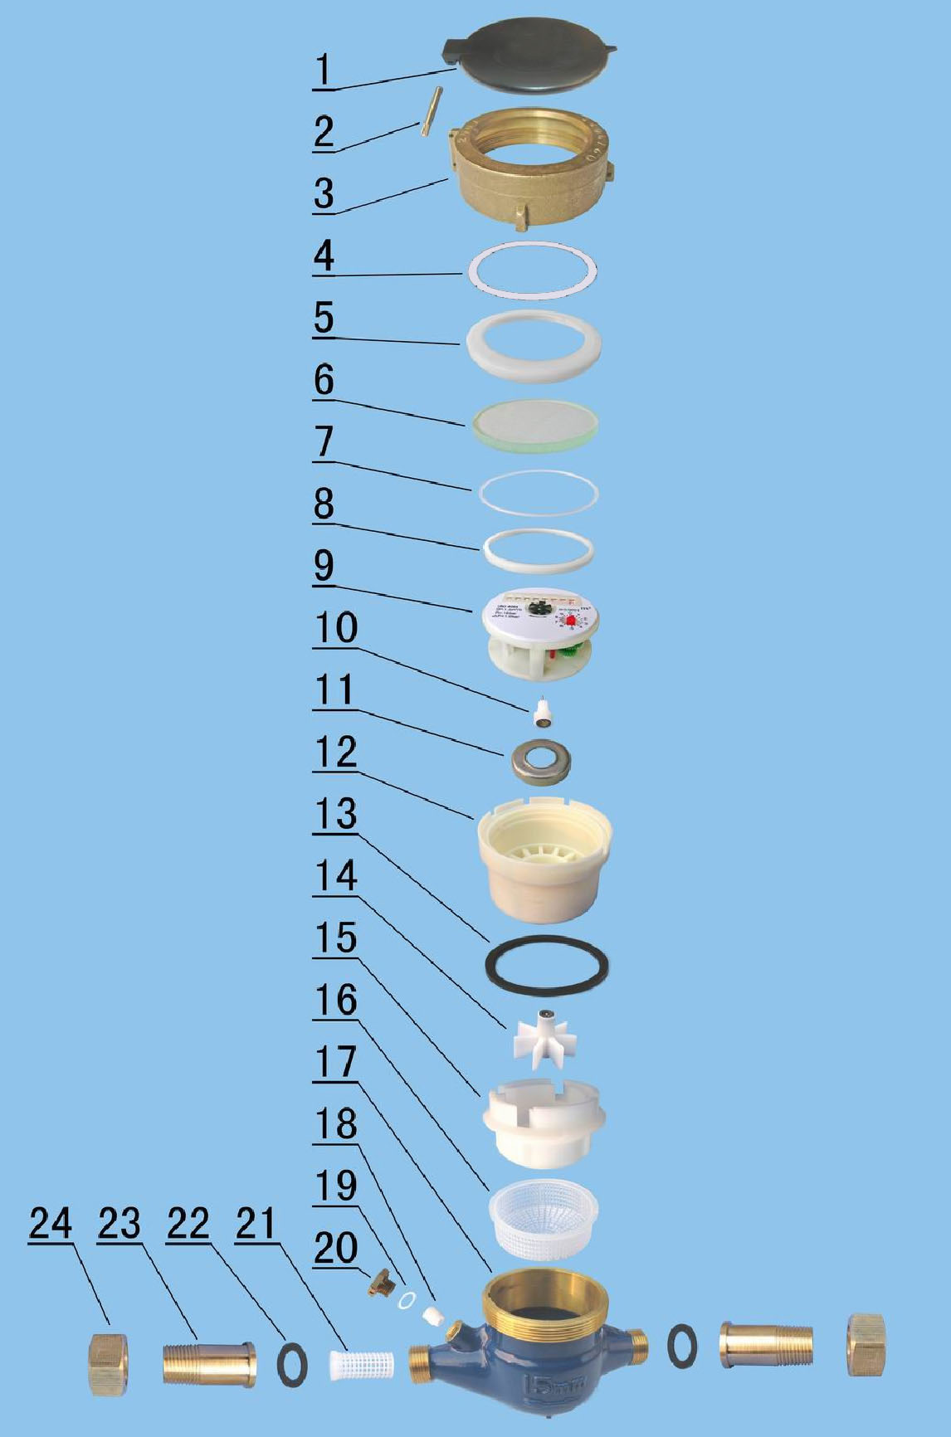

LXSG-15M-20M MULTI-JET, VANE WHEEL, DRY-DIAL WATER METER
Code | Description | Material | QTY
1 | Lid | HDPE | 1
2 | Hinge Pin | Stainless | 1
3 | Cap | Brass | 1
4 | Sliding Gasket | PP | 1
5 | Glass Fixing Ring | ABS | 1
6 | Glass | Tempered Glass | 1
7 | O-ring | Silicon Rubber | 1
8 | Register Fixing Ring | ABS | 1
9 | Register | Assembly | 1
10 | Central Gear | Component | 1
11 | Magnetic Shield Ring | Iron | 1
12 | Gearing box | ABS Plastic | 1
13 | Tightening Gasket | Rubber | 1
14 | Turbine Component | Component | 1
15 | Measuring Chamber | HIPS | 1
16 | Bottom Strainer | LDPE | 1
17 | Body | Brass | 1
18 | Adjusting Screw | POM | 1
19 | Adjusting Gasket | Nylon | 1
20 | Adjusting Plug | Brass | 1
21 | Inlet Strainer | PP | 1
22 | Coupling Gasket | Rubber | 2
23 | Coupling Tail Piece | Brass | 2
24 | Coupling Nut | Brass | 2

LIANYUNGANG HYTTEN METER CO.,LTD.
Add:No. 8 Hanguo Industrial Development Zone,Luoyang Village
Dunshang Town,Ganyu District, Lianyungang, Jiangsu, China
Tel: ++86-518-85907891
Fax: ++86-518-85907890 Postal code: 222000
E-mail: hytten@hyttenmeter.com
http://www.hyttenmeter.com www.hyttenwatermeter.com

